Land Surveyors Act
(Chapter 156, Section 40)
Land Surveyors Rules
R 1
G.N. No. S 199/2000
REVISED EDITION 2002
(31st January 2002)
[15th April 2000]
Citation
1. These Rules may be cited as the Land Surveyors Rules.

PART I
REGISTRATION OF SURVEYORS

Form of application
2.
—(1) An application for registration as a registered surveyor under section 12 of the Act shall be in Form 1 in the First Schedule.
(2) An application for registration under section 12(1)(a)(i) of the Act shall be accompanied by —
(a)
evidence in writing as to age and good character of the applicant;
[S 182/2007 wef 02/05/2007]
(b)
a copy of the certificate of competency issued to the applicant under these Rules or the revoked Land Surveyors Rules (R 1, 1990 Ed.); and
[S 182/2007 wef 02/05/2007]
(c)
evidence in writing that the applicant has passed the professional interview conducted by the Board under section 12(1)(b) of the Act.
[S 182/2007 wef 02/05/2007]
(3) An application for registration under section 12(1)(a)(ii) of the Act shall be accompanied by —
(a)
evidence in writing that the applicant has passed any professional examination set out in the Second Schedule;
(b)
evidence in writing as to age and good character of the applicant;
[S 182/2007 wef 02/05/2007]
(c)
evidence in writing of practical experience in surveying in Singapore; and
[S 182/2007 wef 02/05/2007]
(d)
evidence in writing that the applicant has passed the professional interview conducted by the Board under section 12(1)(b) of the Act.
[S 182/2007 wef 02/05/2007]
(4) An application for registration under section 12(1)(a)(iii) of the Act shall be accompanied by —
(a)
evidence in writing as to age and good character of the applicant;
[S 182/2007 wef 02/05/2007]
(b)
evidence in writing of practical experience in surveying in Singapore; and
[S 182/2007 wef 02/05/2007]
(c)
evidence in writing that the applicant has passed the professional interview conducted by the Board under section 12(1)(b) of the Act.
[S 182/2007 wef 02/05/2007]

Registration fee
3. Every application for registration as a registered surveyor under section 12 of the Act shall be accompanied by a fee of $100.

Professional examinations and practical experience
4. For the purpose of section 12(1)(a)(ii) of the Act —
(a)
the professional examinations recognised by the Board are as set out in the Second Schedule;
(b)
the further examination shall be the examination conducted by the Board specified in rule 27(2); and
(c)
the practical experience in surveying shall comprise practical experience in surveying activities in Singapore at a professional level for not less than one year, obtained after the applicant has passed the professional examination referred to in paragraph (a).

Professional interview
4A. For the purpose of section 12(1)(b) of the Act —
(a)
the applicant shall only apply to attend the professional interview after he has sat for and passed the relevant examination or examinations referred to in section 12(1)(a) of the Act; and
(b)
where an applicant is unsuccessful at a professional interview, he shall be entitled to apply to the Board to attend a subsequent professional interview after the expiry of such period as may be specified by the Board.
[S 182/2007 wef 02/05/2007]

Certificate of registration
5.
—(1) A registered surveyor shall, on payment of a fee of $100, be issued a certificate of registration duly signed by the Registrar.
(2) The certificate of registration shall be in Form 2 in the First Schedule.

Register of surveyors
6. The register of surveyors shall be in Form 3 in the First Schedule.

Removal from register of surveyors
7. An application by a registered surveyor under section 26 (2) of the Act to have his name removed from the register of surveyors shall be in Form 4 in the First Schedule.
[S 158/2005 wef 31/03/2005]
[S 182/2007 wef 02/05/2007]

PART II
PRACTISING CERTIFICATES
Form of application
8.
—(1) An application for a practising certificate shall be in Form 5 in the First Schedule.
(2) An application under paragraph (1) by a registered surveyor subject to Part IIA shall be accompanied by a Continuing Professional Development Programme form evidencing that the applicant has complied with the continuing professional development requirements in that Part.

Practising certificate fee
9. For the purpose of section 15(3)(c) of the Act, a fee of $300 shall be payable in respect of an application for a practising certificate.
[S 158/2005 wef 31/03/2005]

Additional fee for late application
10.
—(1) Where an application for a practising certificate authorising the holder thereof to engage in survey work during any year or part thereof is made on or after 1st January of that year or after 1st December of the previous year, a fee of $50 in addition to the fee specified in rule 9 shall be payable in respect of that application.
(2) Paragraph (1) shall not apply to any first application for a practising certificate after registration under the Act or the repealed Land Surveyors Act (Cap. 156, 1985 Ed.).

Evidence
11. The Board may require a statutory declaration or such other evidence and particulars as it thinks fit to determine whether an applicant shall be issued a practising certificate.

Form of practising certificate
12. A practising certificate shall be in Form 6 in the First Schedule.

Register of practitioners
13. The annual register of practitioners shall be in Form 7 in the First Schedule.

PART IIA
continuing professional development

Definitions of this Part
13A. In this Part —
“continuing professional development unit” means a continuing professional development unit which a registered surveyor obtains by successfully completing any survey related activity or non-survey related activity;
“non-survey related activity” means any activity, course or programme identified under rule 13E(1) or (2) as a non-survey related activity;
“qualifying period”, in relation to a registered surveyor, means a period of 12 months immediately preceding the date he applies for a practising certificate;
“requisite continuing professional development units”, in relation to a registered surveyor, means the number of continuing professional development units he is required to obtain under rule 13C(1);
“survey related activity” means any activity, course or programme identified under rule 13E(1) or (2) as a survey related activity.

Application of this Part
13B. This Part shall apply to every registered surveyor who applies on or after 1st January 2006 for a renewal of his practising certificate authorising him to engage in survey work in Singapore after 31st December 2006.

Requirements as to continuing professional development
13C.
—(1) For the purposes of section 15(3)(b)(ii) of the Act, the requisite continuing professional development units that a registered surveyor is required to obtain during the qualifying period is at least 20 continuing professional development units, of which —
(a)
at least 10 continuing professional development units shall be obtained from successfully completing one or more survey-related activities; and
(b)
the remainder shall be obtained from successfully completing one or more survey related activities or non-survey related activities, or both.
(2) The Board may issue a practising certificate to a registered surveyor notwithstanding that he has failed to obtain the requisite continuing professional development units during the qualifying period if the registered surveyor gives an undertaking that he will obtain the shortfall in the requisite continuing professional development units within 12 months immediately following the last day of the qualifying period.
(3) Any continuing professional development units obtained by the registered surveyor in the circumstances referred to in paragraph (2) shall be disregarded for the purpose of any subsequent application by the registered surveyor for a practising certificate.
(4) Notwithstanding paragraphs (1) and (2), the Board may, in such special circumstances as it may determine, issue a practising certificate to a registered surveyor who has obtained such lower number of continuing professional development units during the qualifying period as the Board may allow.

Board may appoint managing agent
13D.
—(1) The Board may appoint a managing agent to administer and implement the continuing professional development programme.
(2) For the avoidance of doubt, the managing agent shall have no powers in relation to the issuing of practising certificates under Part V of the Act or rule 13C.

List of activities, etc., with continuing professional development units
13E.
—(1) The Board or its duly appointed managing agent shall, for the purposes of this Part, publish on either or both of their Internet websites ––
(a)
the list of activities, courses and programmes under the continuing professional development programme;
(b)
the number of continuing professional development units a registered surveyor will obtain if he successfully completes each of the activities, courses and programmes; and
(c)
whether each of the activities, courses and programmes is a survey related activity or a non-survey related activity.
(2) Notwithstanding paragraph (1), a registered surveyor may, at any time, apply to the Board for any particular activity, course or programme to be recognised as a survey related activity or non-survey related activity for which a registered surveyor will obtain a specified number of continuing professional development units if he successfully completes it.

Issue of guidelines and directives
13F. For the purposes of rules 13C and 13E, the Board may issue such guidelines and directives, not inconsistent with the provisions of these Rules, as the Board considers necessary.

Special provision for applicants for practising certificate for 2007
13G. Where —
(a)
a registered surveyor applies on or after 1st January 2006 for a renewal of his practising certificate authorising him to engage in survey work in Singapore in the year 2007; and
(b)
he has, at any time before 1st January 2006, successfully completed any activity, course or programme that —
(i)
is published on the Internet website of the Board or its duly appointed managing agent, and identified therein as an activity, a course or a programme for which a registered surveyor will obtain a specified number of continuing professional development units if he successfully completes it; or
(ii)
is otherwise recognised by the Board as a survey related activity or a non-survey related activity for which a registered surveyor will obtain a specified number of continuing professional development units if he successfully completes it,
the registered surveyor shall be regarded as having obtained those continuing professional development units during the qualifying period for that application.

PART III
LICENCES

Form of application
14. An application for a licence to supply survey services in Singapore shall be in Form 8 in the First Schedule.

Licence fee
15.
—(1) Every application for a licence shall be accompanied by a fee of $500.
[S 158/2005 wef 31/03/2005]
(2) The fee referred to in paragraph (1) shall not be refundable.

Evidence
16.
—(1) An application by a corporation for a licence shall be accompanied by —
(a)
a certified true copy of the memorandum and articles of association of the corporation;
(b)
a list of the members and directors of the corporation containing particulars as to whether they are registered surveyors, allied professionals or otherwise, and such other particulars as the Board may require;
(c)
a certified true copy of any policy insuring the corporation against professional liability in accordance with the Act for such period as the corporation is licensed to supply survey services;
[S 182/2007 wef 02/05/2007]
(d)
a certified true copy of the certificate of incorporation issued in respect of the corporation under section 19 of the Companies Act (Cap. 50); and
[S 182/2007 wef 02/05/2007]
(e)
a certified true copy of the resolution passed by the board of directors of the corporation under section 17(1)(d)(ii) or (2) (c) (iii) of the Act.
[S 182/2007 wef 02/05/2007]
(2) An application for a licence by a partnership not comprising wholly of registered surveyors shall be accompanied by —
(a)
a copy of the agreement establishing the partnership; and
(b)
a list of the partners of the partnership containing particulars as to whether they are registered surveyors, allied professionals or otherwise, and such other particulars as the Board may require.
(3) For the purpose of section 17(4)(b) of the Act, the type of limited liability partnership which may apply for a licence is one where at least one of its partners is a registered surveyor who has in force a practising certificate and the other partner or each of the other partners is —
(a)
a registered surveyor or an allied professional who has in force a practising certificate;
(b)
a limited corporation which has in force a licence issued under section 17(1) of the Act, section 20(1) of the Professional Engineers Act (Cap. 253) or section 20(1) of the Architects Act (Cap. 12);
(c)
an unlimited corporation which has in force a licence issued under section 17(2) of the Act, section 20(2) of the Professional Engineers Act or section 20(2) of the Architects Act; or
(d)
a limited liability partnership which has in force a licence issued under section 17(4) of the Act, section 20(4) of the Professional Engineers Act or section 20(4) of the Architects Act.
[S 182/2007 wef 02/05/2007]
(4) An application for a licence by a limited liability partnership shall be accompanied by —
(a)
a certified true copy of the statement lodged by the partners of the limited liability partnership with the Registrar of Limited Liability Partnerships under section 15(1) of the Limited Liability Partnerships Act (Cap. 163A);
(b)
a certified true copy of the resolution passed by the partners of the limited liability partnership under section 17(4)(d)(ii) of the Act;
(c)
a list of the partners of the limited liability partnership containing particulars as to whether the partners are registered surveyors, allied professionals, licensed corporations or licensed limited liability partnerships, and such other particulars as the Board may require; and
(d)
a certified true copy of any policy insuring the limited liability partnership in accordance with section 21 of the Act for the period the limited liability partnership is licensed to supply the survey services.
[S 182/2007 wef 02/05/2007]
(5) The Board may require an applicant for a licence to furnish a statutory declaration to support any facts or particulars contained in his application or such other evidence or particulars as the Board considers necessary to determine whether to issue a licence.
[S 182/2007 wef 02/05/2007]

Validity of licence
17. Every licence shall be valid for a period of 12 months from the date of its issue.

Form of licence
18. A licence to supply survey services in Singapore shall be in Form 9 in the First Schedule.

Appeal
19. An appeal under section 17(8) or 18(4) of the Act against any decision of the Board to refuse to grant a licence or to impose any condition on a licence, as the case may be, shall —
(a)
be made not more than 30 days after the decision of the Board has been notified to the appellant;
(b)
be addressed to the Permanent Secretary, Ministry of Law;
(c)
set out the grounds of appeal; and
(d)
be accompanied by a copy of the following documents:
(i)
the decision of the Board and the reasons therefor;
(ii)
the application for the licence and all documents accompanying that application; and
(iii)
any other correspondence between the Board and the appellant in relation to the refusal to grant the licence or the conditions of the licence, as the case may be.

Register of licensees
20. The register of licensees shall be in Form 10 in the First Schedule.

PART IV
EXAMINATIONS

Conduct of examinations
21.
—(1) Examinations conducted by the Board for the purpose of section 12(1)(a) of the Act shall be held at least once a year.
[S 182/2007 wef 02/05/2007]
(2) The Board shall appoint examiners and supervisors for such examinations.

Date of examination
22. The Board shall circulate a notice of the date, time and place at which each examination will be held in such form and manner as the Board sees fit, the date of the examination being a date at least 3 months from the date of the notice.

Application to sit for examination
23.
—(1) An application to sit for an examination in any subject shall be in writing and lodged with the Registrar not later than the date by which such applications must be received, as the Board may determine.
(2) Every application to sit for an examination in any subject shall be accompanied by —
(a)
evidence of having passed any examination set out in the Second Schedule; and
(b)
an examination fee of $150 for each subject to be taken in the examination.
[S 158/2005 wef 31/03/2005]

Withdrawal of application
24.
—(1) The Board may, for sufficient cause, permit any candidate to withdraw his application for an examination and may refund the whole or part of any fees paid by him.
(2) For the purpose of paragraph (1), the candidate shall notify the Board in writing of his intention to withdraw his application at least 2 weeks before the date of the examination.
[S 158/2005 wef 31/03/2005]

Refund of fees
25. If the Board refuses to permit any candidate to present himself for examination, the Board shall refund any fees paid by such candidate for the examination.

Examination number
26. Every candidate taking written examinations shall be allotted an index number, with which he shall mark each page of the workings and papers submitted by him but he shall not otherwise reveal his identity thereon.

Examination subjects
27.
—(1) Subject to paragraph (3), for the purpose of section 12(1)(a)(i) of the Act, the prescribed examination shall consist of the following:
(a)
the examinations conducted before 9th December 1999 by the Singapore Polytechnic for its Advanced Diploma in Land Surveying; and
(b)
the oral and practical examinations conducted by the Board in the following subjects:
(i)
Open Lot Survey;
(ii)
Built on Lot Survey;
(iii)
Strata Survey;
(iv)
Levelling;
(v)
Engineering Survey;
(vi)
Topographical Survey; and
(vii)
Land Development.
(2) For the purpose of section 12 (1) (a) (ii) of the Act, the further examination shall consist of the following:
(a)
in the case of a person who has, before 1st September 2005, passed the examination in Open Lot Survey or Built on Lot Survey or both subjects, and has not completed the further examination —
(i)
the written examination conducted by the Board in the subject Cadastral Law; and
(ii)
the oral and practical examinations conducted by the Board in the following subjects:
(A)
Open Lot Survey;
(B)
Built on Lot Survey; and
(C)
Strata Survey; and
(b)
in all other cases —
(i)
the written examination conducted by the Board in the subject Cadastral Law; and
(ii)
the oral and practical examinations conducted by the Board in the following subjects:
(A)
Land Lot Survey; and
(B)
Strata Survey.
(3) Paragraph (1) shall cease to apply upon the expiry of 7 years from 15th April 2000.

Original plans
28.
—(1) A candidate for an examination in the subjects referred to in rule 27(1)(b)(i), (ii) and (iii) and (2)(a)(ii) and (b)(ii) shall, in addition to the evidence and fees specified in rule 23(2) —
(a)
submit to the Board his original field notes, relevant calculations and plans drawn therefrom of —
(i)
in respect of the open lot survey, the survey of one or more lots, 2 of the boundaries of which shall coincide with and be reinstated from previous surveys;
(ii)
in respect of the built on lot survey, the survey of lots with buildings on or near the boundaries and involving exact fixation of party wall and other walls;
(iii)
in respect of the strata survey, the strata survey of a building;
[S 158/2005 wef 31/03/2005]
(iv)
in respect of the land lot survey —
(A)
the survey of one or more lots, 2 of the boundaries of which shall coincide with and be reinstated from previous surveys; and
(B)
the survey of lots with buildings on or near the boundaries and involving exact fixation of party wall and other walls; and
(b)
give to the Board such additional information as it may require in regard to his professional service, field notes and plans.
(2) Each plan to be submitted under paragraph (1)(a) shall bear the following certificate signed by the candidate:
“
 | I hereby certify that this survey was made by me personally between the ................... day of .................. 20 ........... and the ............... day of ................... 20 ........., and that this plan and the accompanying field notes are entirely my own work.
 | ...................................... | ................................................
 | Date | Date Signature of candidate
”

Passing of examinations
29.
—(1) No person shall be regarded as having passed the examination required for the purpose of section 12 (1)(a)(i) of the Act unless he —
(a)
successfully completed the Advanced Diploma in Land Surveying course with the Singapore Polytechnic and obtained his Diploma before 9th December 1999; and
(b)
obtains at least 60% of the marks in every subject specified in rule 27(1).
(2) No person shall be regarded as having passed the further examination for the purpose of section 12(1)(a) (ii) of the Act unless —
(a)
he obtains at least 60% of the marks in every subject specified in rule 27(2)(a) or (b); and
(b)
except where the Board for special reason directs otherwise in respect of any particular person, he does so within 7 years from the date he was first notified by the Registrar, whether before, on or after 31st March 2005, that he has passed any subject in the further examination, regardless when his application to sit for any subject in the further examination was made.

Misconduct in relation to examination
30.
—(1) The supervisor of an examination may refuse to allow a candidate to continue with the examination if the candidate has misconducted himself in relation to the examination.
(2) Where the supervisor refuses to allow a candidate to continue with the examination under paragraph (1), the supervisor shall report the candidate and his reasons for the refusal to the Board.
(3) If the Board is of the opinion that the conduct of the candidate during such examination warrants his exclusion from all subsequent examinations to be conducted by the Board for one year from the time the supervisor refused to allow the candidate to continue with the examination, the Board may exclude the candidate from those examinations during that year.

Appeal for review of paper
31.
—(1) Any candidate who has received a notification from the Registrar advising him that he has failed in any subject at the examination may, within 2 weeks from the date of that notification, appeal to the Board to review his paper in that subject, and the Board shall, upon the receipt of a fee of $100 for each subject to be reviewed, allow such a review.
(2) In the event the candidate succeeds in his appeal, the Board shall refund the fee paid to the candidate.

Certificate of competency
32. A certificate of competency shall —
(a)
be in Form 11 in the First Schedule; and
(b)
be issued to each candidate who passes the examination specified in rule 27(1).

PART V
MISCELLANEOUS

33. [Deleted by S 158/2005 wef 31/03/2005]

34. [Deleted by S 158/2005 wef 31/03/2005]

Inspection of register
35. A fee of $10 shall be payable to the Board in respect of each inspection of the register of surveyors, an annual register of practitioners or the register of licensees.

FIRST SCHEDULE
FORM 1
Rule 2(1)
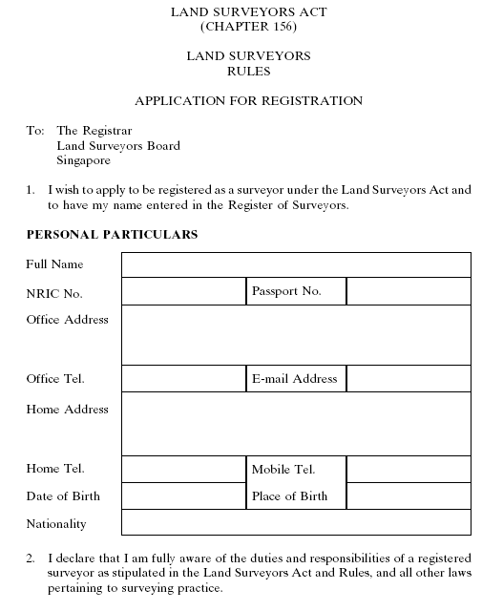
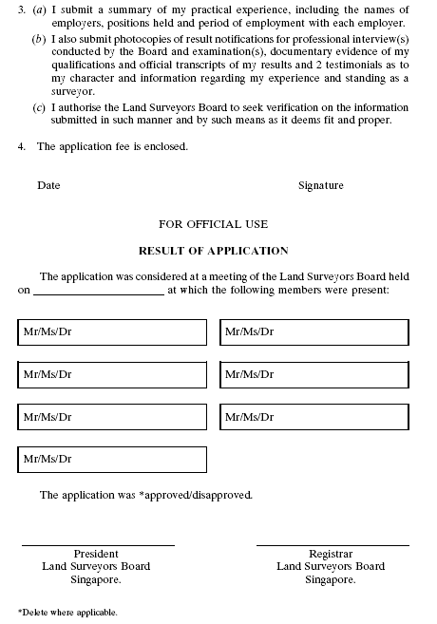
[S 182/2007 wef 02/05/2007]
FORM 2
Rule 5(2)
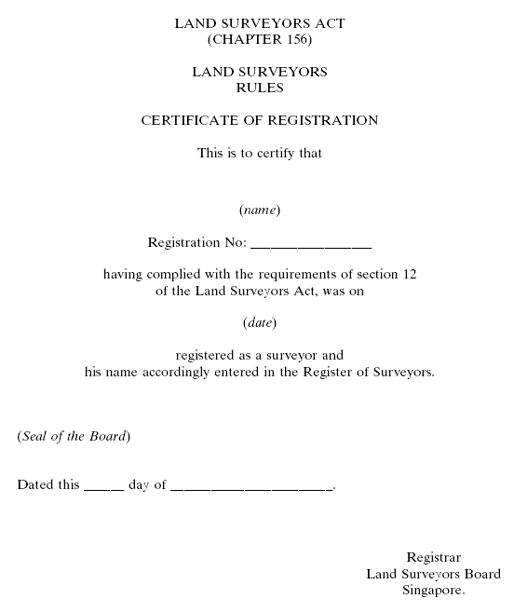
[S 182/2007 wef 02/05/2007]
FORM 3
Rule 6
LAND SURVEYORS ACT
(CHAPTER 156)
LAND SURVEYORS RULES
REGISTER OF SURVEYORS
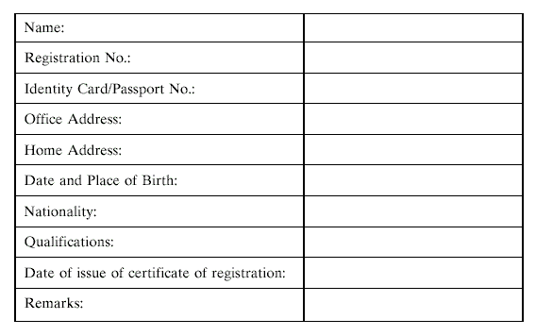
FORM 4
Rule 7
LAND SURVEYORS ACT
(CHAPTER 156)
LAND SURVEYORS RULES
To: |  | The Registrar,
 |  | Land Surveyors Board,
 |  | Singapore.
I, .............................................................. , apply under section 31(2) of the Land Surveyors Act to have my name removed from the Register of Surveyors. My affidavit for this application is attached.
2. There is neither any disciplinary action pending against me, nor is my conduct the subject of inquiry or investigation by an Investigation Committee.
3. I return the following certificates for cancellation:
 |  | (a) Certificate of Registration No. ................................; and
 |  | (b) Practising Certificate No. ..................................... (if any).
4. I hereby declare that the statements made in this form are true and correct.
.............................................. |  | ...................................................
Date |  | Signature of Applicant
[S 158/2005 wef 31/03/2005]
FORM 5
Rule 8
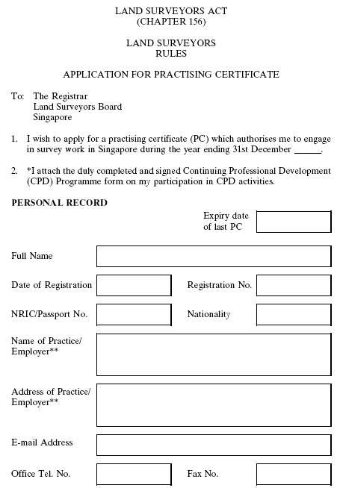
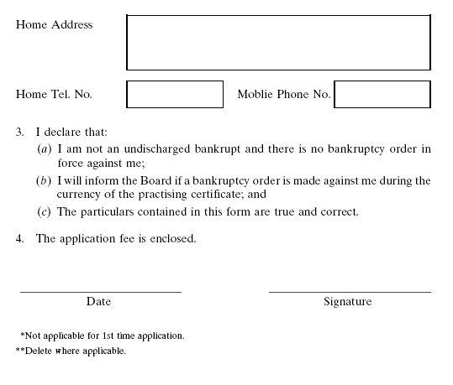
[S 182/2007 wef 02/05/2007]
FORM 6
Rule 12
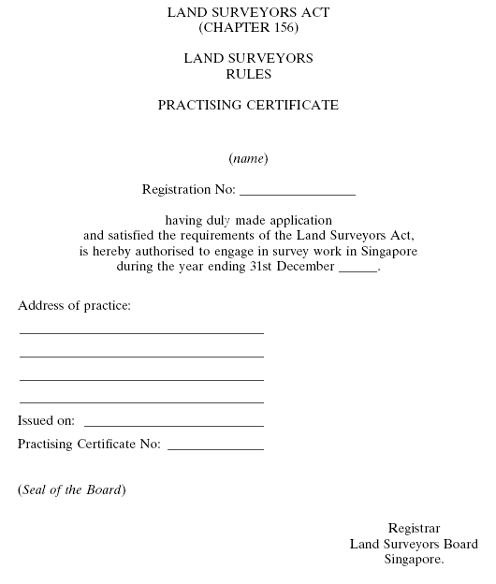
[S 182/2007 wef 02/05/2007]
FORM 7
Rule 13
LAND SURVEYORS ACT
(CHAPTER 156)
LAND SURVEYORS RULES
ANNUAL REGISTER OF PRACTITIONERS FOR THE YEAR ..........
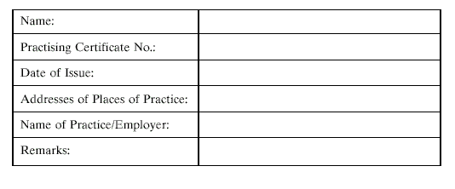
FORM 8
Rule 14
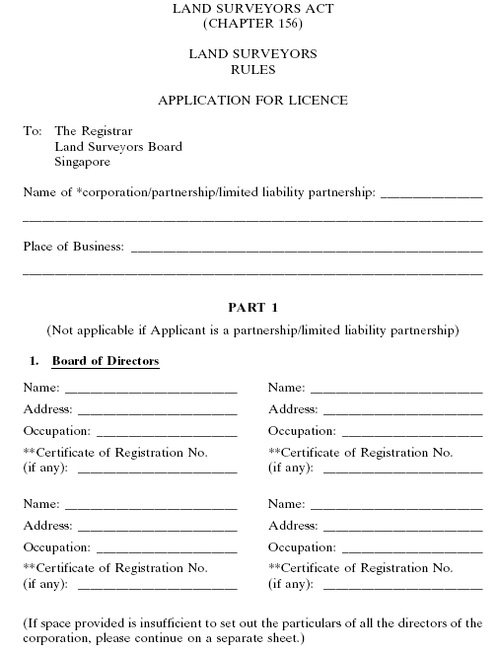
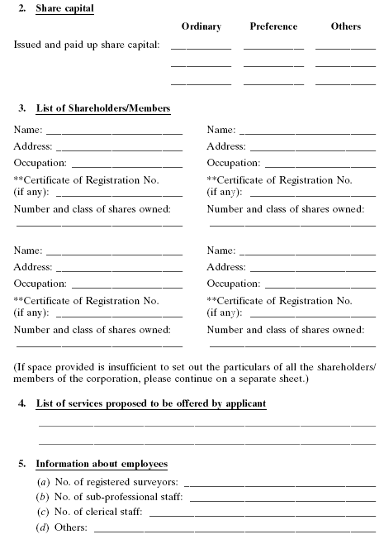
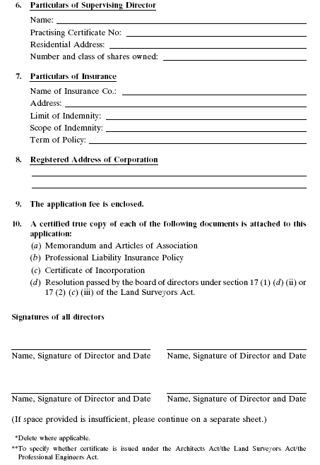
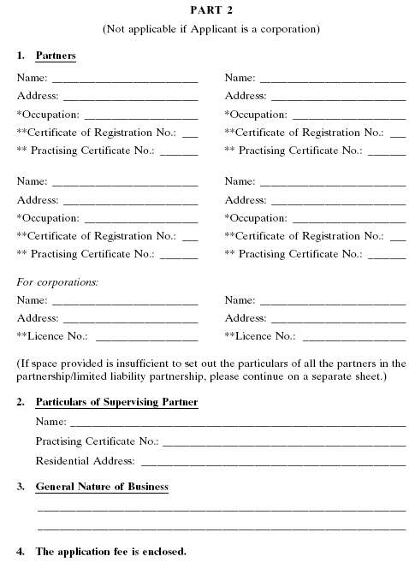
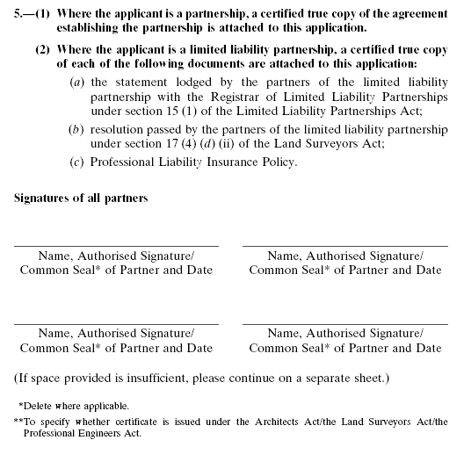
[S 182/2007 wef 02/05/2007]
FORM 9
Rule 18
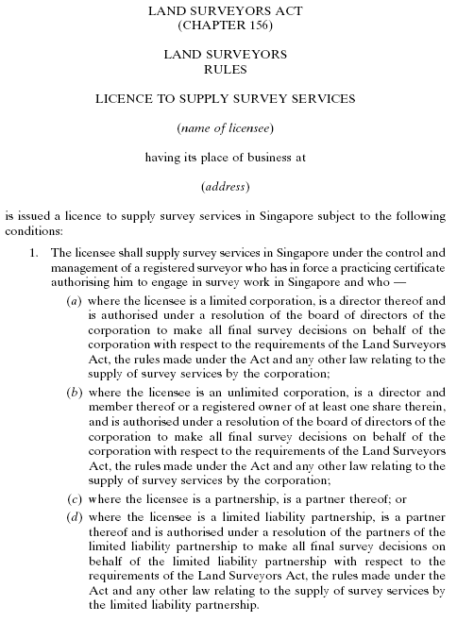
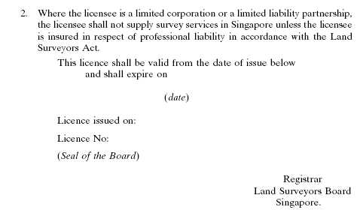
[S 182/2007 wef 02/05/2007]
FORM 10
Rule 20
LAND SURVEYORS ACT
(CHAPTER 156)
LAND SURVEYORS RULES
REGISTER OF LICENSEE
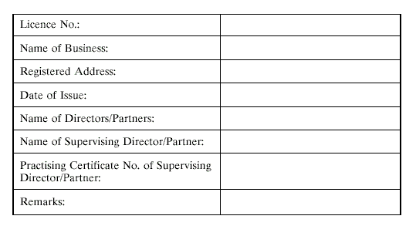
FORM 11
Rule 32
LAND SURVEYORS ACT
(CHAPTER 156)
LAND SURVEYORS RULES
CERTIFICATE OF COMPETENCY
Certificate No. .......................................................
This is to certify that ...................................................................... has duly passed the examination prescribed by the Land Surveyors Board for registration under the Land Surveyors Act.
Dated this ................................. day of .........................................
(Seal of the Board)
Registrar,
Land Surveyors Board,
Singapore.
SECOND SCHEDULE
Rules 2(3), 4 and 23(2)
Recognised Professional Examinations
1. Final examination leading to a Degree of Bachelor of Surveying, Bachelor of Geomatics and Bachelor of Land Information conferred by a recognised university.
2. Any other examination regarded by the Board as an equivalent to the examinations specified in paragraph 1.
[G.N. No.S199/2000]
LEGISLATIVE HISTORY
Land Surveyors Rules
(CHAPTER 156, R 1)
This Legislative History is provided for the convenience of users of the Land Surveyors Rules. It is not part of these Rules.
1. | G. N. No. S 373/1991—Land Surveyors Rules 1991
 | Date of commencement | : | 30 August 1991
2. | 1991 Revised Edition—Land Surveyors Rules
 | Date of operation | : | 25 March 1992
3. | G. N. No. S 412/1996
 | Date of commencement | : | Date not available
4. | G. N. No. S 199/2000—Land Surveyors Rules 2000
 | Date of commencement | : | 15 April 2000
5. | 2002 Revised Edition—Land Surveyors Rules
 | Date of operation | : | 31 January 2002
6. | G. N. No. S 158/2005—Land Surveyors (Amendment) Rules 2005
 | Date of commencement | : | 31 March 2005
7. | G. N. No. S 182/2007—Land Surveyors (Amendment) Rules 2007
 | Date of commencement | : | 2 May 2007

