Maritime and Port Authority of Singapore Act
(Chapter 170A, Section 41)
Maritime and Port Authority of Singapore
(Port) Regulations
Rg 7
G.N. No. S 187/1997
REVISED EDITION 2000
(30th April 2000)
[9th April 1997]
PART I
PRELIMINARY
Citation
1. These Regulations may be cited as the Maritime and Port Authority of Singapore (Port) Regulations.

Definitions
2. In these Regulations, unless the context otherwise requires —
“authorised officer” means —
(a)
any duly authorised employee of the Authority;
(b)
any police or customs officer; or
(c)
any person authorised by the Authority in writing for the purposes of these Regulations;
“Class “A” petroleum” means any petroleum that has a flash point less than 23° Celsius and includes liquefied petroleum gas;
“Collision Regulations” means the Merchant Shipping (Prevention of Collisions at Sea) Regulations (Cap. 179, Rg 10);
“control station” means any Signal Station and any station whose purpose is to aid the direction, or control, of movements of shipping;
“dangerous goods” has the same meaning as in regulation 35 of the Maritime and Port Authority of Singapore (Dangerous Goods, Petroleum and Explosives) Regulations 2005 (G.N. No. S 24/2005);
[S 26/2005 wef 31/01/2005]
“height”, in relation to a vessel, means the height of the vessel measured vertically from the waterline of the vessel to the highest point of the vessel including its cargo, structure or equipment on board;
“ISPS Code” has the same meaning as in Regulation 1 of Chapter XI-2 of the Safety Convention Regulations;
[S 215/2004 wef 01/07/2004]
“Keppel Harbour” means the area of the port from the western extremity of Tanjong Rimau on Sentosa in a straight line to Berlayar Beacon thence along the Singapore coastline to a position Latitude 01 degrees 16.265 minutes N Longitude 103 degrees 51.43 minutes E thence in a straight line to Outer Shoal Beacon thence in a straight line to Buran Beacon thence along northern coastline of Sentosa to Tanjong Rimau;
“laid-up”, in relation to any vessel, means the vessel is not under repair or actively employed;
“main fairway” means any area of the waters of the port specified as a Prohibited Anchorage Area in the Third Schedule;
“MARPOL 73/78” means the International Convention for the Prevention of Pollution from Ships (including its protocols, annexes and appendixes) which constitutes attachment 1 to the final act of the International Conference on Marine Pollution signed in London on 2nd November 1973, as modified and added to by the Protocol of 1978;
“oil terminal” means any place having a permanent means of loading or discharging petroleum, whether in bulk or packaged, into or from any vessel;
“operator”, in relation to a port facility, means a person other than the Authority who, for the time being, manages the port facility;
[S 215/2004 wef 01/07/2004]
“passenger” means any person carried in a ship, except —
(a)
a person employed or engaged in any capacity on board the ship on the business of the ship;
(b)
a person on board the ship either —
(i)
pursuant to the obligation on the master to carry shipwrecked, distressed or other persons; or
(ii)
by reason of any circumstance that neither the master nor the charterer (if any) could have prevented or forestalled; and
(c)
a child below one year of age;
“petroleum” includes —
(a)
the liquids commonly known by the names of Rock oil, Rangoon oil, Burma oil, kerosene, paraffin oil, petrol, gasoline, benzol, benzoline, benzine or naptha; and
(b)
any like flammable liquid, whether —
(i)
a natural product; or
(ii)
a product made from petroleum, coal, schist, shale or any other bituminous substance;
“port facility” has the same meaning as in Regulation 1 of Chapter XI-2 of the Safety Convention Regulations;
[S 215/2004 wef 01/07/2004]
“port facility security plan” means a plan approved by the Authority that is developed to ensure the application of measures designed to protect —
(a)
the port facility; and
(b)
ships, persons, cargo, cargo transport units and ship stores within the port facility,
from the risks of a security incident;
[S 215/2004 wef 01/07/2004]
“recognised security organisation” has the same meaning as in Regulation 1 of Chapter XI-2 of the Safety Convention Regulations;
[S 215/2004 wef 01/07/2004]
“Safety Convention Regulations” means the Merchant Shipping (Safety Convention) Regulations (Cap. 179, Rg 11);
[S 215/2004 wef 01/07/2004]
“sea-going vessel” means any vessel going beyond Singapore port limits;
“security incident” has the same meaning as in Regulation 1 of Chapter XI-2 of the Safety Convention Regulations;
[S 215/2004 wef 01/07/2004]
“ship” means any type of vessel used in navigation by water, however propelled or moved, and includes —
(a)
a barge, lighter, mobile offshore drilling unit, high speed craft or other floating vessel; or
(b)
an air-cushioned vehicle or other similar craft used wholly or primarily in navigation by water;
[S 215/2004 wef 01/07/2004]
“Statement of Compliance” means a Statement of Compliance issued by the Authority in respect of a port facility under regulation 63C;
[S 215/2004 wef 01/07/2004]
“towage” means any operation in connection with holding, pushing, pulling, or moving, or attending for that purpose, any vessel;
“underway”, in relation to a vessel, means that the vessel is not —
(a)
at anchor;
(b)
moored or berthed alongside a wharf or jetty;
(c)
made fast to the shore; or
(d)
aground;
“vehicle” means any vehicle whether mechanically propelled or otherwise.

Information required by Port Master or Authority prior to arrival or departure of vessel or while vessel is in port
3.
—(1) The owner, agent, master or person-in-charge of a vessel entering or leaving the port shall —
(a)
prior to the arrival or departure of the vessel; or
(b)
if the vessel is within the port, prior to any movement of the vessel,
inform the Port Master or the Authority, in the manner determined by the Port Master or the Authority, of the particulars of the vessel including its type, draught, length, beam and height.
(2) The master or person-in-charge of any vessel required to be under pilotage shall, prior to the movement of the vessel, give the pilot information as to the type of vessel, its draught, length, beam and height, its manoeuvring characteristics, the peculiarities of the vessel and any abnormal circumstances of the vessel which may affect its safe navigation.
(3) The owner, agent, master or person-in-charge of a vessel shall inform the Port Master —
(a)
of the estimated time of arrival or departure of the vessel; and
(b)
while the vessel is in the port, of the position of the vessel.
(4) The owner, agent, master or person-in-charge of a vessel shall give the Authority all the information the Authority may reasonably require relating to the cargo on board, to be loaded on, or to be discharged from, the vessel.
(5) If the Port Master or a pilot is not satisfied with the information provided under paragraph (1) or (2), the owner, agent, master or person-in-charge of the vessel shall —
(a)
immediately ascertain the accuracy of the information required; and
(b)
if the information relates to the height of the vessel, measure the height of the vessel, if necessary.
(6) In the case of a tow, the information required under paragraph (1) or (2) shall be provided by the owner, agent, master or person-in-charge of the tow.
(7) Any owner, agent, master or person-in-charge of a vessel who contravenes or fails to comply with paragraph (1) or (2) shall be guilty of an offence and shall be liable on conviction to a fine not exceeding $10,000.

Power-driven vessel to be installed with transponder
3A.
—(1) The owner, agent, master or person-in-charge of a power-driven vessel not under tow shall, at all times while the vessel is within the port, ensure that there is installed and maintained in operation on board the vessel a transponder of a type and specification —
(a)
that complies with the requirements of an automatic identification system (AIS) in Regulation 19(b)(iv)(5) of Chapter V of the Safety Convention Regulations, which sets out the requirements in Chapter V of the International Convention for the Safety of Life at Sea 1974 as amended from time to time; or
(b)
that is approved for use within the port by the Authority or the Port Master.
(2) Without prejudice to the powers of the Port Master under any written law, if the Port Master is not satisfied that a transponder is installed and maintained in operation on board the power-driven vessel, or that the transponder on board the power-driven vessel complies with the requirements of paragraph (1), he may —
(a)
prohibit or delay the entry or departure of the vessel;
(b)
restrict or prohibit the movement of the vessel within the port and the approaches to the port;
(c)
board the vessel and inspect —
(i)
the transponder; or
(ii)
the vessel or any part of the vessel for the purpose of locating the transponder;
(d)
cause the vessel to be detained if, in his opinion, such detention is necessary; and
(e)
by notice served on the owner, agent, master or person-in-charge of the vessel, direct that there be installed and maintained in operation on board the vessel a transponder within such time as the Port Master may determine.
(3) Any person who —
(a)
contravenes or fails to comply with paragraph (1);
(b)
tampers or interferes with the normal operation of any transponder on any vessel; or
(c)
contravenes or fails to comply with any direction issued by the Port Master under paragraph (2)(a), (b) or (e),
shall be guilty of an offence and shall be liable on conviction to a fine not exceeding $20,000 and, in the case of a continuing offence, to a further fine not exceeding $2,000 for every day or part thereof during which the offence continues after conviction.
[S 679/2011 wef 01/01/2012]
Change of ownership or agency
4.
—(1) An owner or agent of a vessel who informs or represents to the Authority, whether by himself or through any agent, that he is the owner or agent of the vessel must inform the Authority immediately of any change of ownership or agency, as the case may be, that occurs while the vessel is in the port.
(2) If an owner or agent of a vessel fails to comply with paragraph (1), he shall be liable, notwithstanding the change of ownership or agency, to pay to the Authority any dues, rates and fees that an owner or agent of a vessel, as the case may be, is liable to pay under any written law up to the time that he informs the Authority of the change of ownership or agency.
(3) Nothing in this regulation affects the liability of a new owner or agent to pay any dues, rates and fees that an owner or agent of a vessel, as the case may be, is liable to pay under any written law but the Authority is not entitled to recover the same set of dues, rates and fees twice.

PART II
DISTRESS, EMERGENCY AND SAFETY

Fire, stranding, grounding or collision
5.
—(1) In the event of a fire on board any vessel, or any stranding, grounding or collision involving any vessel, the master or person-in-charge of the vessel shall —
(a)
take immediate steps to prevent any further deterioration in the condition of the vessel;
(b)
inform the Port Master of the event without any delay by the most direct means;
(c)
state whether assistance from other vessels, or from the Authority, is required and the nature of such assistance;
(d)
sound and exhibit such appropriate sound and visual signals as have been specified in the International Code of Signals, the Collision Regulations or as prescribed by the Authority from time to time;
(e)
ensure that every assistance is given by the crew of the vessel to any other person rendering assistance to the vessel;
(f)
inform the Port Master without delay by the most direct means when further assistance is not required;
(g)
submit a full written report of the circumstances of the incident or occurrence to the Port Master, specifying any damage that may affect the seaworthiness of such vessel —
(i)
within 24 hours of that incident or occurrence; or
(ii)
before any further application for port clearance is made; and
(h)
where port clearance has been granted, surrender the port clearance to the Authority and make a fresh application for port clearance.
(2) The master, and any other officer, person-in-charge and member of the crew, of the vessel referred to in paragraph (1) shall comply with all instructions given by the Port Master.

Emergency or accident
6. In the event of an emergency on a vessel, or an accident to a vessel, that is not provided for in regulation 5, the master or person-in-charge of the vessel shall —
(a)
inform the Port Master of the emergency or accident without delay by the most direct means and comply with any instruction that the Port Master may give; and
(b)
submit, within 24 hours of the emergency or accident or before leaving the port, whichever is the earlier, a written report to the Port Master on the accident or emergency.

Inquiry
7.
—(1) The Port Master may hold an inquiry into the circumstances of any fire on board a vessel, any stranding or grounding of a vessel, any collision involving a vessel, or any accident or damage to a vessel.
(2) For the purposes of such inquiry, the Port Master or his authorised representative may —
(a)
board any vessel and inspect —
(i)
the vessel or any part of the vessel; and
(ii)
any machinery, boats, equipment or articles on board;
(b)
enter and inspect any premises the entry or inspection of which appears to him to be necessary;
(c)
by notice under his hand, require the attendance of any person to give any evidence or produce any document or other thing in his possession relating to the subject-matter of the inquiry; and
(d)
cause the vessel to be detained if in his opinion such detention is necessary.
(3) Any person who being notified to attend any such inquiry fails to do so or who refuses to answer any question relating to the subject-matter of the inquiry or refuses or fails to give any document or other thing shall be guilty of an offence and shall be liable on conviction to a fine not exceeding $2,000.

Distress
8. The owner, agent, master or person-in-charge of a vessel which is in distress in the port shall —
(a)
call up the appropriate control station on the VHF channel that is in use; or
(b)
exhibit all possible distress signals specified in the Collision Regulations or in the First Schedule.

Adequate crew on board
9.
—(1) The owner, agent, master or person-in-charge of a vessel shall at all times ensure that the vessel is sufficiently and efficiently manned.
(2) The owner, agent, master or person-in-charge of a vessel at anchor shall at all times have on board the vessel a sufficient number of men —
(a)
capable of veering cable and keeping anchor lights burning; and
(b)
for taking appropriate action in case of an emergency.
(3) The Port Master may, in respect of any vessel or class of vessels, from time to time stipulate the number of men required under paragraph (2).
(4) The owner, agent, master or person-in-charge of any vessel who contravenes or fails to comply with this regulation shall be guilty of an offence and shall be liable on conviction to a fine not exceeding $10,000.

Secured moorings alongside
10. The master or person-in-charge of a vessel shall ensure that his vessel is at all times adequately secured and that the moorings are tended, as may be required by the rise and fall of the tide, the passing of other vessels or adverse weather conditions.

Responsibility for insecure moorings
11. The Authority shall not be responsible for —
(a)
the improper or insecure moorings of any vessel;
(b)
any defective moorings or appliance; or
(c)
damage or consequences arising from paragraph (a) or (b).

Responsibility for safety when alongside
12. A vessel which berths at any wharf remains under the charge of the master or officer-in-charge who shall take all steps necessary to preserve the safety and security of such vessel.
Use of searchlight
13. No person, other than a person in the employ of the Authority or the Government, shall use a searchlight without the written permission of the Port Master, except —
(a)
in an emergency situation; or
(b)
where the searchlight is on a fire-fighting vessel.

Restrictions on use of bright lights
14.
—(1) No person shall exhibit a bright light in such a manner as to endanger navigation or impede aids to navigation.
(2) The Port Master may direct any person exhibiting, or having control of, such a light to alter or remove the light.

Prohibition on smoking and conditions for carrying out repairs on board vessel
15.
—(1) No person shall smoke, or otherwise create or display any naked light, in or near any part of a vessel unless permitted to do so by the master or person-in-charge.
(2) Repairs to any vessel shall be carried out in conformity with all relevant safety requirements including the following:
(a)
repairs may only be carried out on the instructions of the master or person-in-charge of the vessel;
(b)
the master or person-in-charge of a vessel is responsible for the supervision of repairs to the vessel;
(c)
the master or person-in-charge of a vessel shall ensure that all reasonable precautions are taken to prevent the outbreak of fire or an explosion; and
(d)
the owner, agent, master or person-in-charge of a vessel shall ensure that all workmen carrying out repairs to the vessel are provided with protective clothing and appliances as specified in section 62 of the Factories Act (Cap. 104).

Access to vessel
16.
—(1) The owner, agent, master or person-in-charge of a vessel that is at anchor or secured to a wharf shall —
(a)
provide efficient and easy means of access to and from the vessel by the vessel’s accommodation ladder or gangway; and
(b)
ensure that the means of access —
(i)
is adequately illuminated from sunset to sunrise and when visibility is poor or restricted; and
(ii)
is provided with manropes, nets and such appliances as may be necessary for the convenience and safety of persons.
(2) The owner, agent, master or person-in-charge of a vessel shall ensure that all open hatchways and other deck openings are efficiently guarded by life-lines at all times if the openings are not permanently guarded by hatch coamings.
(3) All railings and fencing of hatchways, accommodation ladders and gangways shall be of substantial construction, constantly maintained and kept in position.
(4) The owner, agent, master or person-in-charge of a vessel shall ensure that all deck machinery and cargo working equipment (including derricks, cranes, wires, slings, trays, pallets, nets and ropes) are maintained in such order and condition as to pose no risk or danger to life or property.

PART III
SIGNALS

Exhibition of navigational lights, shapes and signals
17.
—(1) All vessels shall exhibit —
(a)
lights and shapes required for vessels of their type and size as prescribed by the Collision Regulations; and
(b)
the signals specified in the First Schedule.
(2) Vessels of less than 12 metres in length, except those engaged in diving operations, when not required to exhibit the lights prescribed in rule 27 of the Collision Regulations, shall exhibit an all-round white light.
(3) It is the duty of the owner, agent, master or person-in-charge of a vessel to ensure that the vessel exhibits the lights and shapes required under this regulation.
(4) Nothing in these Regulations shall exonerate the owner, agent, master or crew of a vessel from the consequence of any neglect —
(a)
to carry lights or exhibit shapes;
(b)
to keep a proper look-out; or
(c)
to take any precaution which is required by the ordinary practice of seamen or by the special circumstances of the case.

Use of sound signals in port
18. The owner, agent, master or person-in-charge of a vessel shall use, or permit the use of, only the sound signals specified in the International Code of Signals, the Collision Regulations or the First Schedule.

Display of national colours
19. The master of every sea-going vessel, other than a locally licensed fishing vessel entering or leaving the port between sunrise and sunset, shall cause to be displayed her national colours.

PART IV
RADIO COMMUNICATION

Definitions and application of this Part
20.
—(1) In this Part, unless the context otherwise requires —
“channel” means a channel for telecommunication by radio;
“designated communications centre” means a communications centre designated by the Authority for the purposes of this Part;
“GRT” means the gross registered tonnage of a vessel as specified in the vessel’s certificate of registration;
“report” means a report by radiotelephone that is made, or required to be made, to a designated communications centre by a vessel under regulation 22(4) or 25(2);
“required radiotelephone” means the radiotelephone required to be installed on board a vessel under regulation 21(1);
“specified channel” means the channel stated in regulation 21(1) or the channel specified by the Port Master under that provision;
[S 472/2005 wef 20/07/2005]
“underway”, in relation to a vessel, means that the vessel is not at anchor, made fast to the shore or aground;
“VHF” means very high frequency.
(2) This Part shall apply to —
(a)
a self-propelled vessel exceeding 300 GRT;
(b)
a tugboat engaged in towing where the combined GRT of the tugboat and the vessel that is being towed exceeds 300 GRT;
(c)
a port limit tanker; and
(d)
a port limit passenger vessel.

Vessel to have radiotelephone
21.
—(1) The owner, agent, master or person-in-charge of a vessel shall ensure that there is installed on board the vessel a radiotelephone that is capable of operating in the International Maritime Mobile VHF Radiocommunication Service in the 156-174 MHz Band or such channel as may be specified by the Port Master from time to time.
(2) The prescribed radiotelephone shall at all times be maintained in an effective working condition and be available for operation on the navigational bridge of the vessel.
(3) The master of a vessel shall ensure that the specified channel is used only for communications relating to the operational handling, movement or safety of the vessel or (in an emergency) the safety of persons.
[S 472/2005 wef 20/07/2005]
Radiotelephone to be listened to
22.
—(1) The master of a vessel that is underway within the port shall ensure that the prescribed radiotelephone is listened to continuously on the specified channel.
(2) Paragraph (1) shall not apply to a vessel where —
(a)
a transmission from the vessel on the specified channel is in progress;
(b)
permission is granted by a designated communications centre to transmit on a channel other than the specified channel, in which case the master of the vessel shall ensure that the prescribed radiotelephone is listened to continuously on that channel, except when a transmission from the vessel on that channel is in progress;
(c)
permission to stop listening to the prescribed radiotelephone is granted by the person-in-charge of a designated communications centre; or
(d)
it is not possible for any reason to operate the prescribed radiotelephone.
(3) If it is not possible to operate the prescribed radiotelephone, the master of the vessel shall at the earliest practicable time restore it or cause it to be restored to effective working condition.
(4) The master of a vessel shall as soon as practicable report to a designated communications centre if —
(a)
it is not possible to operate the required radiotelephone; or
(b)
the prescribed radiotelephone is restored to effective working condition under paragraph (3).

Direction to master of vessel
23.
—(1) Where the person-in-charge of a designated communications centre is of the opinion that there is any congestion of vessels, reduced visibility or other hazardous condition within the port, he may direct the master of any vessel as to when and where the vessel shall enter, move within or through, or depart from the port.
[S 472/2005 wef 20/07/2005]
(2) The person-in-charge of a designated communications centre may direct the master of a vessel to cease making any communication using the specified channel.
[S 472/2005 wef 20/07/2005]
Exemption
24.
—(1) The person-in-charge of a designated communications centre may, subject to such conditions as he may impose and upon a request from the master of a vessel, exempt the master from any provision of, or any direction given under, regulations 21 to 23 and 25 to 27.
(2) The master of a vessel shall, in making a request under paragraph (1), state the manner in which he wishes to be exempted from any provision or direction referred to in that paragraph and the reason for requesting the exemption.
(3) Any exemption granted under this regulation shall not reduce or in any way affect the responsibility of the master of a vessel to whom the exemption is granted for the vessel or for any person, cargo or property on board.

Failure to comply with regulations
25.
—(1) Where the master of a vessel is, in any emergency affecting the safety of any person or property, unable to comply —
(a)
with any provision of, or any direction given under, regulations 21 to 24, 26 and 27; or
(b)
with any condition imposed under regulation 24(1),
he shall take such steps as may be necessary to avoid endangering any person and to avoid any damage to any property or the environment.
(2) If the master of a vessel fails to comply with —
(a)
any provision of, or any direction given under, regulations 21 to 24, 26 and 27; or
(b)
any condition imposed under regulation 24(1),
he shall forthwith report the failure to the person-in-charge of a designated communications centre.

Report
26.
—(1) Every report made for the purposes of these Regulations shall be in English.
(2) Where any time is specified in any report, or in any communication from a designated communications centre, the time shall be specified in —
(a)
local time; and
(b)
the 24-hour clock system.

Compliance with direction
27. The master of a vessel shall comply with any direction given by the Port Master or the person-in-charge of a designated communications centre for the purposes of regulations 21 to 26.

PART V
CONTROL OF NAVIGATION

Collision Regulations applicable to vessels navigating or at anchor
28. For the purposes of navigation and anchoring of vessels the Collision Regulations shall apply.

Restricted entry into Keppel Harbour, East Johore Strait and Damar Laut Channel and Jurong River
29.
—(1) No person shall cause or permit a vessel exceeding 30 metres in length, or exceeding 30 metres in height, to enter, manoeuvre within or leave Keppel Harbour or the East Johore Strait without —
(a)
notifying the respective control stations of its intention to do so; and
(b)
obtaining the necessary permission to enter, manoeuvre within or leave, as the case may be.
(2) No person shall cause or permit a vessel above 30 metres in length to enter, manoeuvre within or leave Damar Laut Channel or Jurong River without —
(a)
notifying the control station of its intention to do so; and
(b)
obtaining the necessary permission to enter, manoeuvre within or leave, as the case may be.
(3) For the purposes of this regulation where a tow astern is involved, the total length of a towing vessel and the vessel or vessels under tow is to be considered as the length of the towing vessel.
(4) Any person who contravenes or fails to comply with paragraph (1) or (2) shall be guilty of an offence and shall be liable on conviction to a fine not exceeding $20,000 or to imprisonment for a term not exceeding 6 months or to both.

Restriction on movement in wharves and docks
30. No person shall cause or permit a vessel to proceed alongside, lie alongside or leave any wharf, dock, pier, berth or mooring contrary to the directions of the Port Master.

Prohibition of vessels other than harbour craft securing alongside one another
31.
—(1) No person shall cause or permit a vessel to be secured alongside another vessel at anchor without the prior permission of the Port Master and except under such conditions as the Port Master may impose.
(2) This regulation shall not apply in respect of a licensed harbour craft.

Crossing main fairway
32.
—(1) The owner, agent, master or person-in-charge of a vessel crossing a main fairway shall ensure that the vessel keeps clear of other vessels proceeding along the fairway.
(2) The owner, agent, master or person-in-charge of a vessel engaged in towing shall ensure that the vessel does not impede the passage of a vessel that can safely navigate only within a narrow channel or fairway.
(3) This regulation shall not apply to a vessel engaged in towing if the vessel is restricted in her ability to manoeuvre.

Negligent navigation prohibited
33.
—(1) No person shall cause or permit a vessel to be navigated —
(a)
in a reckless or negligent manner; or
(b)
at such a speed or in any way that is —
(i)
dangerous; or
(ii)
likely to cause injury to persons, or damage to property or other vessels.
(2) No person shall cause or permit a vessel to proceed at any speed that is inconsistent with safe navigation, or contrary to the speed restrictions imposed by the Port Master from time to time.
(3) Speed restrictions imposed by the Port Master under paragraph (2) do not apply —
(a)
to a fire-fighting vessel proceeding to a fire;
(b)
to a craft engaged in rescue operations;
(c)
to an Authority or a Government craft on urgent duty; or
(d)
to any other craft where a temporary increase in speed is necessary in order to avoid immediate danger.

Foul berth
34. No person shall cause or permit a vessel to anchor in such a manner as to give a foul berth to another vessel already anchored.

Laid-up vessels
35.
—(1) No person shall cause or permit a vessel to be laid-up in the port without the prior written permission of the Port Master and except under such conditions as the Port Master may impose.
(2) The owner, agent, master or person-in-charge of a laid-up vessel berthed in a laid-up anchorage shall ensure that such vessel is so anchored or moored as to be able to swing within the limits of anchorage, and to keep clear of all other vessels and any fishing stakes set up therein, during all conditions of wind and tide.

Port Master may require vessel to leave port
36. The Port Master may direct a vessel to leave the port if he is of the opinion that it would not be in the interest of the Authority for the vessel to remain in port.

Damaged vessels entering port
37. No person shall cause or permit a damaged vessel to enter the port without the prior permission of the Port Master who may grant the permission subject to such conditions as he thinks fit.

PART VI
VESSELS BERTHED ALONGSIDE

Berthing at private wharve
38. No person shall cause or permit a vessel —
(a)
to proceed alongside, or lie alongside, any place without the consent of the owner or person-in-charge of the place; or
(b)
to anchor or moor in the approaches to such a place so as to cause obstruction to other vessels.

PART VII
SPECIFIED PLACES FOR LOADING AND UNLOADING CARGO AND PUBLIC LANDING PLACES

Authorised piers and places for discharging or loading cargo
39.
—(1) No owner, agent, master or person-in-charge of a vessel shall discharge cargo from the vessel onto any pier or place except —
(a)
at piers and places specified in the Customs (Authorised Piers and Places for Import by Sea) Regulations (Cap. 70, Rg 6); and
(b)
at such other places approved by the Authority, from time to time, for the purpose,
and except under such conditions as the Authority thinks fit to impose.
(2) No owner, agent, master or person-in-charge of a vessel shall load, or cause to be loaded, cargo from any pier or place onto the vessel except —
(a)
at piers and places authorised for such purposes under the Customs (Authorised Piers and Places for Transhipment, Export and Transit by Sea) Regulations (Cap. 70, Rg 5); and
(b)
at such other places approved by the Authority, from time to time, for the purpose,
and except under such conditions as the Authority thinks fit to impose.
(3) A person who, having requested that a place be approved for the purposes of paragraph (2), is aggrieved by the refusal of the Authority to give its approval, may refer the matter to the Minister whose decision is final.
(4) No owner of any pier or place that is —
(a)
not specified in —
(i)
the Customs (Authorised Piers and Places for Import by Sea) Regulations (Cap. 70, Rg 6); or
(ii)
the Customs (Authorised Piers and Places for Transhipment, Export and Transit by Sea) Regulations (Cap. 70, Rg 5); or
(b)
approved by the Authority pursuant to this regulation,
shall permit the loading or discharging of cargo from the pier or place.

Loading or discharging of Class “A” petroleum
40. No owner, agent, master or person-in-charge of a vessel shall load or discharge, or cause to be loaded or discharged, Class “A” petroleum at any place except —
(a)
at an oil terminal; or
(b)
subject to such conditions as the Port Master may impose, at any other place that is declared by the Port Master as a landing place for loading or discharging Class “A” petroleum.

Loading or discharging of dangerous goods
41. No owner, agent, master or person-in-charge of a vessel shall load or discharge, or cause to be loaded or discharged, dangerous goods at any place except, subject to such conditions as the Port Master may impose —
(a)
an anchorage or wharf; or
(b)
any other place that has been declared by the Port Master as a landing place for loading or discharging dangerous goods.

Public landing places
42.
—(1) The public landing places are Jardine Pier, Clifford Pier and West Coast Ferry Terminal 2.
(2) No person shall cause or permit a vessel other than a harbour craft to lie alongside a public landing place.
(3) No person shall cause or permit a harbour craft to lie alongside any public landing place longer than is necessary to embark or disembark persons or load or discharge baggage.
(4) No person shall on any public landing place —
(a)
sell, hawk or peddle any goods;
(b)
tout or solicit business or trade of any kind; or
(c)
loiter.
(5) No person shall cause or permit a vessel other than a harbour craft to embark or disembark passengers unless the place is authorised by the Port Master for that purpose.

PART VIII
SPECIAL ANCHORAGES
Special anchorages
43.
—(1) The special anchorages, and the purposes for which they may be used, are set out in the Second Schedule.
(2) The owner, agent, master or person-in-charge of a vessel which uses any anchorage referred to in the Second Schedule for a purpose other than that specified in that Schedule, or in a manner contrary to the Port Master’s directions, shall be guilty of an offence under these Regulations.
Ship to ship transfer prohibited
44. No person shall cause or permit a vessel to undertake ship to ship transfer of bulk liquid without the written permission of the Port Master and except under such conditions as the Port Master may impose.

PART IX
PROHIBITIONS AND RESTRICTIONS

Fairways and Prohibited Anchorage Areas
45.
—(1) The Fairways and Prohibited Anchorage Areas are specified in the Third Schedule.
(2) The Port Master may at any time by notice restrict or prohibit the movement of a vessel or class of vessels in the port but the notice must state the period of the prohibition, the area to which it is applicable, the nature of the prohibition and whether the prohibition relates to anchorage or passage or such other purposes as he may require.
(3) The owner, agent, master or person-in-charge of a vessel —
(a)
which uses that part of the sea in any of the areas referred to in paragraph (1) contrary to any restriction or prohibition imposed by these Regulations or by the Port Master; or
(b)
which is in breach of any restriction or prohibition imposed by the Port Master in paragraph (2),
shall be guilty of an offence.

No vessel to make fast to any bridge or railing
46. No person shall cause or permit a vessel to make fast to any bridge or railing.

Obstruction of anchorage, fairway or wharf
47.
—(1) No person shall cause or permit a vessel to anchor, moor, lie or loiter in such a manner as to obstruct the approach to any anchorage, wharf or landing place used by other vessels.
(2) No person shall cause or permit a vessel to anchor in any fairway or to lie in a position as may obstruct any fairway.

Vessels not to remain at special anchorage for longer than necessary
48. No person shall cause or permit a vessel to remain at a special anchorage for a period that is longer than is necessary for the intended purpose.
PART X
PROHIBITIONS AND RESTRICTIONS IN HEIGHT RESTRICTED AREA

Prohibitions and restrictions in Height Restricted Area
49.
—(1) For the purposes of this regulation, “Height Restricted Area” means the areas of the port within Keppel Harbour bounded by the line joining the position 1° 15.599’N 103° 48.531’E to the position 1° 15.760’N 103° 48.425’E, thence eastward along the coastline to position 1° 15.788’N 103° 49.507’E, thence along the western side of the road link to the position 1° 15.395’N 103° 49.509’E, thence westward along the northern coastline of Pulau Sentosa to the point of origin in position 1° 15.599’N 103° 48.531’E.
(2) No person shall cause or permit a vessel above 52 metres in height to enter the Height Restricted Area.
(3) No person shall cause or permit a vessel in the Height Restricted Area to be modified to attain a height above 52 metres.
(4) Subject to paragraph (3), the owner, agent, master or person-in-charge of a vessel which is to be modified to attain a height above 48 metres while the vessel is within the Height Restricted Area shall —
(a)
prior to the modification give the Port Master written notice of the intention to modify the vessel; and
(b)
comply with such conditions as the Port Master may impose on the modifications or the movement of the vessel.
(5) Subject to paragraph (2), no person shall cause or permit a vessel above 48 metres in height to enter, manoeuvre within or leave the Height Restricted Area unless the owner, agent, master or person-in-charge of the vessel obtains the prior written approval of the Port Master and complies with such conditions as the Port Master may impose.
(6) The owner, agent, master or person-in-charge of a vessel who contravenes or fails to comply with this regulation shall be guilty of an offence and shall be liable on conviction to a fine not exceeding $20,000 or to imprisonment for a term not exceeding 6 months or to both.

PART XI
OBSTRUCTIONS

Mooring of hulks
50.
—(1) No person shall moor, anchor or beach any hulk within the waters of the port without the written permission of the Port Master and except under such conditions as the Port Master may impose.
(2) For the purposes of this regulation, “hulk” means a vessel which is unfit to withstand the ordinary perils of the sea.
(3) No person shall cause or permit a vessel to be beached within the port without the written permission of the Port Master and except under such conditions as the Port Master may impose.

Rafts of logs and timber
51.
—(1) No person shall cause or permit logs to be discharged into or stored in the water at any place other than the special area specified in the Second Schedule.
(2) No person shall cause or permit a raft of logs or timber to be towed except with the permission of the Port Master and except under such conditions as the Port Master may impose.
(3) A person who causes or permits logs to be discharged into or stored in the water, or rafts of logs or timber to be towed, shall ensure that the logs or rafts of logs or timber when afloat carry at a height of not less than 2 metres —
(a)
at each end of the log or raft a red flag not less than 70 centimetres square by day, and a white light, which must be visible all round from a distance of at least 4 kilometres by night; and
(b)
if the length of the log or raft exceeds 15 metres, an additional red flag by day and white light by night in the centre of the logs or raft.

PART XII
SPECIAL OPERATIONS

Launching of new vessels
52. No person shall cause or permit a newly constructed vessel of more than 15 metres in length to be launched, or to be placed into the waters of the port, without the prior written permission of the Port Master and except under such conditions as the Port Master may impose.

Breaking-up vessels
53. No person shall cause or permit a vessel to be broken up either wholly or in part without the permission of the Port Master and except under such conditions as the Port Master may impose.

Submarine cables and pipelines
54.
—(1) No person shall lay, lift, repair or inspect any submarine cable or pipeline —
(a)
without the prior permission of the Port Master; and
(b)
without giving the Port Master 24 hours’ notice in writing before doing the same.
(2) The Port Master may in giving such permission impose such conditions as he considers appropriate in the circumstances of the case.
(3) The owner of a submarine cable or pipeline shall —
(a)
relay such cable or pipeline if it is found to be outside an area approved by the Port Master; and
(b)
remove any cable or pipeline that is no longer in use.
(4) No person shall, within the port limits, carry out, or cause to be carried out, any underwater diving operation or repair, except with the approval of the Port Master who may impose any condition as he thinks fit.

Vessels under fumigation
55. The owner, agent, master or person-in-charge of a vessel requiring fumigation services shall use the services provided by the Authority or by contractors duly licensed by the Authority.

Restriction on heating of combustible matter
56.
—(1) No owner, agent, master or person-in-charge of a vessel shall, without the permission of the Port Master, permit the heating, boiling or burning of any pitch, tar, resin, wax, flammable liquid, oil, refuse, rubbish or other combustible matter in any vessel.
(2) The Port Master may in giving such permission impose any condition he thinks fit.
(3) The permission of the Port Master is not required where the heating, boiling or burning of such pitch, tar, resin, wax, flammable liquid, oil, refuse, rubbish or other combustible matter is carried out in an approved shipyard.

PART XIII
TOWING OPERATIONS

Restriction on provision of towage and other assistance
57. No person shall, in relation to any vessel or object in the port, provide towage or other forms of assistance without the permission of the Authority.

Authority to be engaged for towage and other assistance
58.
—(1) Except with the written permission of the Authority, a person who, in respect of any vessel or object in the port, requires towage or other forms of assistance shall make use of towage or other forms of assistance provided by the Authority on such terms and conditions as the Authority thinks fit.
(2) Paragraph (1) does not apply in respect of any vessel belonging to the Government.
Conditions of towage and assistance by other persons
59. Where permission has been obtained for a person, other than the Authority, to tow or otherwise assist any vessel or object in the port, the person towing or otherwise assisting the vessel or object shall comply with the following conditions:
(a)
every vessel or object being towed or assisted must be under the proper and seamanlike control of the tug;
(b)
not more than one vessel or object is to be secured to any one side of the tug;
(c)
not more than 4 vessels or objects in the aggregate is to be towed, or otherwise assisted, in line by any single tug; and
(d)
if 2 or more vessels are to be towed, the distance from the stern of any tug to the stern of the last vessel or object towed, as the case may be, shall not exceed 300 metres.

PART XIV
BOARDING, BERTHING OR PROCEEDING ALONGSIDE VESSELS

Boarding, berthing or proceeding alongside vessels
60.
—(1) No person shall —
(a)
cause or permit a vessel to proceed alongside, or attempt to proceed alongside, any other vessel which is making way; or
(b)
board, or attempt to board, a vessel making way.
(2) This provision does not apply to pilot vessels on duty.

Boarding of vessels
61.
—(1) No person shall —
(a)
cause or permit a vessel to approach within 200 metres of a vessel exhibiting the appropriate quarantine signals; or
(b)
board a vessel exhibiting the appropriate quarantine signals while the vessel is in the Quarantine and Immigration Anchorage.
(2) No person shall cause or permit a vessel to approach within 200 metres of, or board, a vessel that —
(a)
is in a Quarantine and Immigration Anchorage; or
(b)
exhibits the appropriate signals indicating that the vessel requires, or is undergoing, customs or immigration clearance, or both.
(3) No person shall, without the consent of the master of a vessel —
(a)
cause or permit the vessel to proceed alongside or lie alongside any other vessel; or
(b)
board the vessel.
(4) This regulation shall not apply —
(a)
to an authorised officer of the Authority or Government; or
(b)
to an Authority or a Government vessel.

PART XV
REGULATION OF NAVIGATION IN RIVERS
Speed limits
62.
—(1) No person shall cause or permit a vessel navigating in a river to proceed at a speed exceeding 5 knots.
(2) This regulation does not apply to Authority crafts, Government launches or fire-fighting vessels proceeding on urgent duty.

General prohibitions
63. No person shall cause or permit a vessel —
(a)
to anchor in a manner as to obstruct a fairway or the approach to any river; or
(b)
to be made fast to any bridge or railing, or other object on land that is not intended for that purpose.

PART XVA
PORT SECURITY
[S 215/2004 wef 01/07/2004]
Security requirements for ship entering or within port
63A.
—(1) When any ship enters or is within the port, the owner, agent or master of the ship shall ensure that the ship complies with the requirements of Chapter XI-2 of the Safety Convention Regulations and Part A of the ISPS Code that are relevant to the ship, taking into account the guidance given in Part B of the ISPS Code.
(2) The Port Master —
(a)
shall communicate the security levels set for, and provide security level information to, any ship that enters or is within the port; and
(b)
may require the owner, agent or master of the ship to provide the information referred to in regulation 9(b) of Chapter XI-2 of the Safety Convention Regulations.
(3) Any owner, agent or master of a ship who —
(a)
contravenes paragraph (1); or
(b)
fails to provide any information required by the Port Master under paragraph (2)(b),
shall be guilty of an offence and shall be liable on conviction to a fine not exceeding $10,000.

Security requirements for port facility
63B.
—(1) The owner or operator of any port facility shall ensure that —
(a)
the port facility complies with the requirements of Chapter XI-2 of the Safety Convention Regulations and Part A of the ISPS Code that are relevant to the port facility, taking into account the guidance given in Part B of the ISPS Code;
(b)
there is a valid Statement of Compliance issued in respect of the port facility before the port facility is used as such; and
(c)
the port facility undergoes an intermediate verification exercise in accordance with regulation 63C(3).
(2) Any owner or operator of a port facility who contravenes paragraph (1) shall be guilty of an offence and shall be liable on conviction to a fine not exceeding $10,000.

Statement of Compliance
63C.
—(1) The Authority shall issue a Statement of Compliance in respect of a port facility if, at the date the Statement of Compliance is issued, the port facility complies with —
(a)
the requirements of the ISPS Code that are relevant to the port facility; and
(b)
such additional requirements as the Authority may impose.
(2) Subject to paragraph (4), a Statement of Compliance shall be valid for a period of 5 years from the date it is issued.
(3) Where a Statement of Compliance has been issued in respect of a port facility —
(a)
the port facility shall undergo an intermediate verification exercise conducted by a recognised security organisation to determine whether, as at the date of the intermediate verification exercise, the port facility complies with —
(i)
the requirements of the ISPS Code that are relevant to the port facility; and
(ii)
such additional requirements as the Authority may impose; and
(b)
the intermediate verification exercise shall be conducted between 24 months and 36 months from the date the Statement of Compliance is issued.
(4) Where it is determined at an intermediate verification exercise that a port facility does not comply with —
(a)
any requirement of the ISPS Code that is relevant to the port facility; or
(b)
any additional requirement imposed by the Authority,
the Authority may suspend the Statement of Compliance until the non-compliance has been rectified or withdraw the Statement of Compliance.

Maintenance of conditions
63D.
—(1) Where a Statement of Compliance has been issued in respect of a port facility, the owner or operator of the port facility shall —
(a)
ensure that all levels of protective security measures and security organisation for the port facility are maintained in accordance with the ISPS Code;
(b)
ensure that —
(i)
a port facility security plan has been implemented in respect of the port facility; and
(ii)
the port facility is operated in compliance with the port facility security plan;
(c)
ensure the continuing relevance and accuracy of the port facility security plan;
(d)
conduct security drills at intervals of not more than 3 months; and
(e)
conduct security exercises at least once in a year, with not more than 18 months between such exercises.
(2) Any owner or operator of a port facility who contravenes paragraph (1) shall be guilty of an offence and shall be liable on conviction to a fine not exceeding $10,000.

Powers of entry and search
63E.
—(1) The Port Master, any authorised officer or any public officer authorised by the Authority may —
(a)
enter, inspect and search any ship or port facility —
(i)
for the purpose of ensuring that the regulations in this Part are complied with; or
(ii)
if he has reasonable grounds for believing that an offence is being or was committed under the provisions of this Part; and
(b)
seize any evidence of the commission of an offence under the provisions of this Part.
(2) No person shall prevent or obstruct the Port Master, any authorised officer or any public officer authorised by the Authority from performing any act under paragraph (1).
(3) Any person who contravenes paragraph (2) shall be guilty of an offence and shall be liable on conviction to a fine not exceeding $2,000.

Submission of information
63F. Any person who, being required to submit information to the Port Master, any authorised officer or any public officer authorised by the Authority —
(a)
for any purpose under regulations 63A to 63D; or
(b)
to comply with any requirement of Chapter XI-2 of the Safety Convention Regulations or Part A of the ISPS Code, taking into account the guidance given in Part B of the ISPS Code,
submits any information which is false, misleading or inaccurate shall be guilty of an offence and shall be liable on conviction to a fine not exceeding $20,000 or to imprisonment for a term not exceeding 6 months or to both.

PART XVB
PROVISION OF FERRY SERVICES
[S 661/2004 wef 01/01/2005]
Licence for provision of ferry services
63G.
—(1) No person shall provide any ferry service to and from Singapore unless he is licensed for that purpose by the Authority.
(2) Every licence granted under this regulation shall be in such form and for such period and shall be subject to such conditions as the Authority may determine.
(3) If, in the opinion of the Authority, the licensee has contravened or failed to comply with any of the conditions of the licence, the Authority may, by notice in writing, cancel the licence or suspend the licence for such period as the Authority considers appropriate.
(4) The Authority may, at any time, vary or revoke any of the existing conditions imposed under paragraph (2) or impose new conditions.

Application for ferry service licence and licence fees
63H.
—(1) Every application for a licence under regulation 63G shall be made to the Authority in such form as the Authority may determine and shall be accompanied by such particulars, information and documents as may be specified by the Authority.
(2) The licensee shall pay such fee as may be determined by the Authority for the issue of the licence to him.

PART XVI
MISCELLANEOUS

Unauthorised trading, hawking or provision of services
64. No person shall, within the port or at the anchorages —
(a)
ply for hire, sell or expose for sale any goods; or
(b)
exchange money, solicit custom or provide any services,
unless he is licensed or authorised for that purpose by the Authority.

Pollution of port waters
65. No person shall, without the permission of the Authority —
(a)
throw, discharge or deposit; or
(b)
cause to be thrown, discharged or deposited,
any ashes, solid ballast, sludge or any other matter into the waters of the port.

Emission of smoke
66. No person shall cause smoke, soot, ash, grit or oil to be emitted from a vessel in such quantity or density as may, in the opinion of the Authority, be a nuisance or an annoyance.

Use of rat guards
67. The master or person-in-charge of a vessel lying at a wharf shall ensure that efficient rat guards are fitted to all moorings.

Use of efficient fenders
68. The master or person-in-charge of a vessel alongside any wharf, dock or other vessel shall provide and use suitable fenders.

Projections from vessels
69. No person shall cause or permit a vessel to anchor, or berth, with anything projecting from, or attached to, the vessel in a manner that may endanger the safety of, or impede, other vessels navigating or moored within the waters of the port.

Engines to have efficient silencers
70. No person shall cause or permit any internal combustion engine to be used on or in a vessel unless the exhaust pipe is fitted with an efficient silencer.

Discharging or loading from vessel underway
71.
—(1) No person shall discharge or load, or attempt to discharge or load, from any vessel which is underway, any goods or passengers’ baggage.
(2) For the purpose of this regulation, a vessel alongside a wharf is deemed to be underway if it is not properly secured to the wharf.

Offences in connection with lighthouse or other aid to navigation
72. Any person who wilfully or negligently —
(a)
damages, removes, alters or destroys a lighthouse or other aid to navigation;
(b)
hinders or prevents a lighthouse or other aid to navigation from being used or operated in the manner in which it is intended to be used or operated; or
(c)
rides by, makes fast to, or runs foul of, a lighthouse or other aid to navigation,
shall, in addition to the expenses of making good any damage occasioned by such acts, be liable on conviction to a fine not exceeding $10,000.

Establishment of moorings and buoys
73.
—(1) No person shall keep or place any moorings or buoys in the waters of the port without the written permission of the Port Master and except under such conditions as the Port Master may impose.
(2) The Port Master may require or cause moorings or buoys kept or placed in contravention of paragraph (1) to be removed.
(3) The person responsible for keeping or placing the moorings or buoys that are required to be removed under paragraph (2) is liable for any expense incurred by the Authority for the removal of the moorings and buoys if he fails to remove the moorings and buoys within the time stipulated by the Port Master.

Supply of water to vessels
74. No person shall supply water to vessels within the port except —
(a)
through the Authority or by agreement with the Authority; and
(b)
under such terms and conditions as the Authority may determine.

Persons under influence of alcohol or drugs
75.
—(1) No person shall take charge of any vessel while he is under the influence of drink or a drug or an intoxicating substance to such extent as —
(a)
to be incapable of having proper control of the vessel; or
(b)
to endanger the safety of the vessel or the crew or any other person.
(2) No person shall board any vessel while he is under the influence of drink or a drug or an intoxicating substance to such extent as to endanger the safety of the vessel or the crew or any other person.
(3) The owner, agent or master of a vessel shall not permit any person to take charge of or board the vessel in contravention of paragraph (1) or (2).

Responsibility of owner, agent, master or person-in-charge for observation of these Regulations
76. Notwithstanding anything contained in these Regulations, the owner, agent, master or person-in-charge of any vessel and the owner of any vehicle shall at all times be responsible for the due observance of and compliance with these Regulations in so far as the same relate to the vessel or vehicle.

Authority may permit use of vessel or port otherwise than in accordance with these Regulations
77.
—(1) The Authority may, in its discretion, permit —
(a)
any person to use a vessel or the port; or
(b)
any vessel to be used within the port,
otherwise than in accordance with any of the provisions of these Regulations.
(2) The Authority may in granting its permission under paragraph (1) impose such conditions as it thinks fit.

Penalty
78. Any person who —
(a)
without lawful excuse fails to comply with the requirements of any notice served on him; or
(b)
contravenes or fails to comply with any provision of these Regulations,
shall be guilty of an offence and shall be liable on conviction where no special penalty is provided to a fine not exceeding $5,000 and, in the case of a continuing offence, to a further fine not exceeding $1,000 for every day or part of the day during which the offence continues after conviction.

Application to Singapore Armed Forces
79. Regulations 26, 28, 42 and 48 shall apply to a vessel belonging to the Singapore Armed Forces and the officer in command of such a vessel shall ensure that the requirements of those regulations are complied with.
Savings
80. Any request, inquiry, approval, permission, order, exemption or agreement made or given under the revoked provisions of the Singapore Port Regulations (Cap. 236, Rg 6) is deemed to have been made or given under the corresponding provisions of these Regulations.

FIRST SCHEDULE
Regulations 8, 17(1) and 18
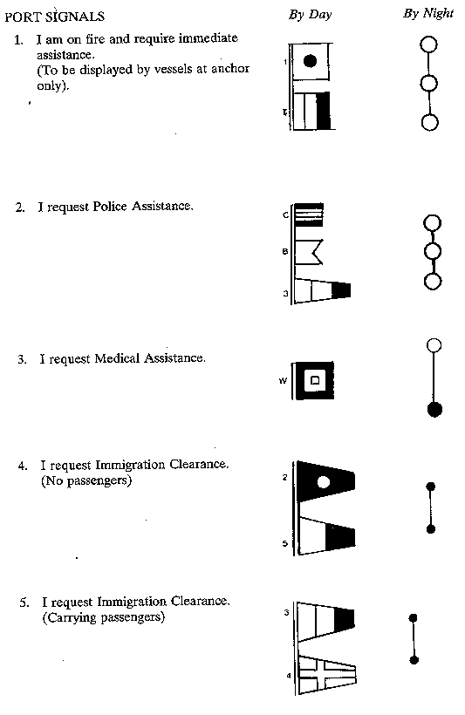
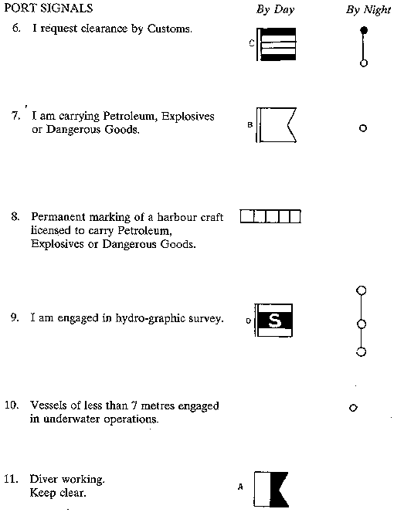
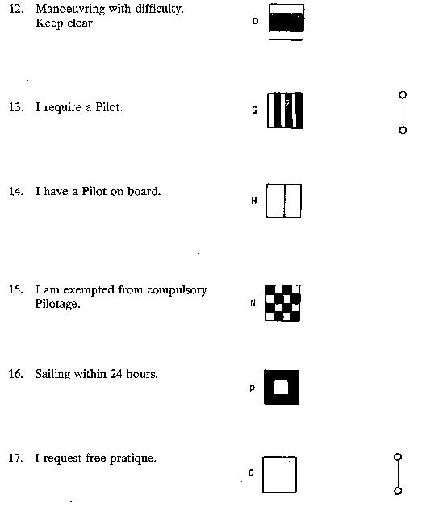
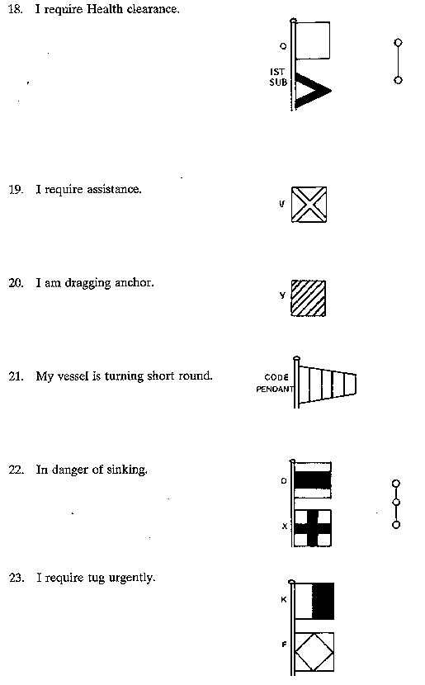
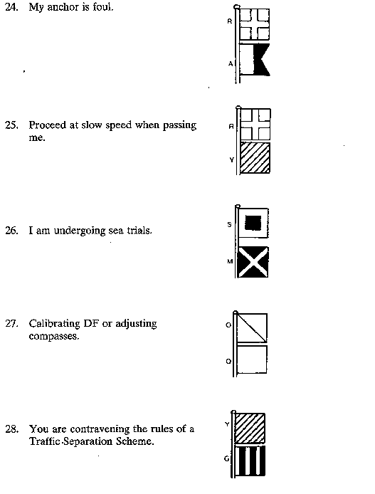
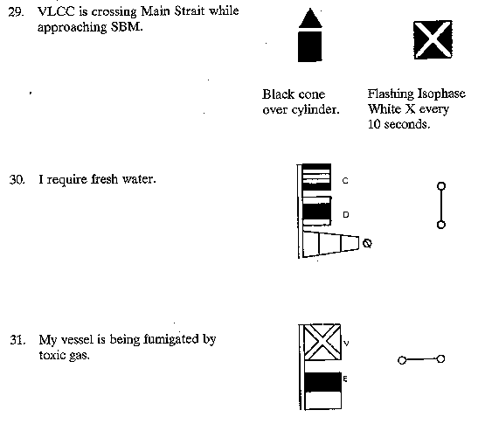
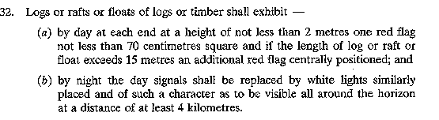
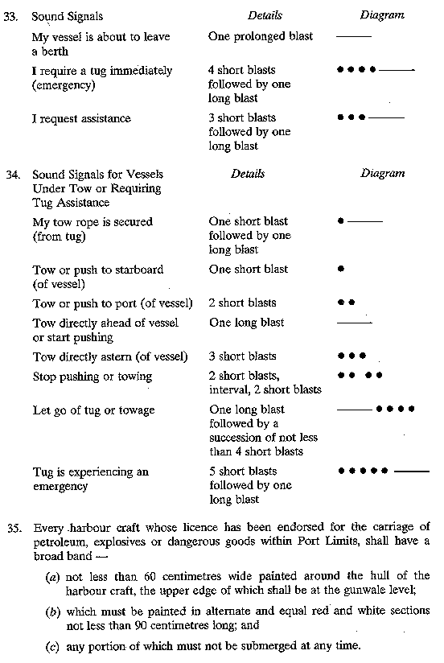
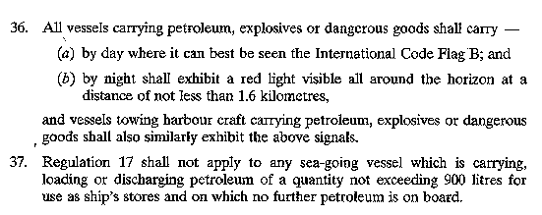
SECOND SCHEDULE
Regulations 43 and 51
Special Anchorages
The Special Anchorages designated by the Authority are as set out below. The geographical positions of the designated Special Anchorages are based upon the origin at the Government Offices Building being in Latitude 1° 17’ 15.528”N Longitude 103° 51’ 10.808”E. The Special Anchorages are charted in Singapore Nautical Charts numbered SP1, GSP1, 100, 101, 102, 103, 104, 105, 300, G300, 301, G301, 302, G302, 303, G303, 304, G304, 500, 501 and 502.
1. The following anchorages shall be used exclusively for the purposes stated in this Schedule.
1.1. Changi General Purpose Anchorage is bounded by a line joining the following geographical positions:
(1) 1° 20.000’N |  | 104° 03.706’E
(2) 1° 18.880’N |  | 104° 04.820’E
(3) 1° 18.880’N |  | 104° 04.281’E
(4) 1° 19.550’N |  | 104° 03.667’E
(5) 1° 20.000’N |  | 104° 03.167’E
Purpose — For general purpose on prior permission of the Port Master.
1.2. Eastern Petroleum “B” Anchorage is bounded by a line joining the following geographical positions:
(6) 1° 17.500’N |  | 103° 59.083’E
(7) 1° 17.650’N |  | 104° 01.200’E
(8) 1° 16.629’N |  | 103° 59.313’E
(9) 1° 16.629’N; |  | 103° 59.082’E
Purpose — For vessels of 50,000 GRT and above for the primary purpose of bunkering, and other vessels on prior permission of the Port Master.
1.3. Eastern Special Purpose “B” Anchorage is bounded by a line joining the following geographical positions:
(10) 1° 17.979’N |  | 103° 56.617’E
(11) 1° 18.300’N |  | 103° 57.438’E
(12) 1° 18.300’N |  | 104° 00.450’E
(13) 1° 17.650’N |  | 104° 01.200’E
(14) 1° 17.500’N |  | 103° 59.083’E
(15) 1° 17.979’N |  | 103° 57.723’E
Purpose — For vessels under arrest, damaged vessels or vessels requiring repairs, and other vessels on prior permission of the Port Master.
1.4. Eastern Petroleum “C” Anchorage is bounded by a line joining the following geographical positions:
(16) 1° 17.979’N |  | 103° 56.617’E
(17) 1° 17.979’N |  | 103° 57.723’E
(18) 1° 17.500’N |  | 103° 59.083’E
(19) 1° 17.500’N |  | 103° 56.617’E
Purpose — For vessels loaded with petroleum and non-gas free vessels.
1.5. Eastern Special Purpose “A” Anchorage is bounded by a line joining the following geographical positions:
(20) 1° 17.500’N |  | 103° 56.617’E
(21) 1° 17.500’N |  | 103° 59.083’E
(22) 1° 16.629’N |  | 103° 59.082’E
(23) 1° 16.633’N |  | 103° 56.617’E
Purpose — For vessels under arrest, damaged vessels, deep draught vessels, vessels requiring repairs, and other vessels on prior permission of the Port Master.
1.6. Laid-up Vessels Anchorage is bounded by a line joining the following geographical positions:
(24) 1°17.784’N |  | 103°56.117’E
(25) 1°17.979’N |  | 103°56.617’E
(26) 1°16.633’N |  | 103°56.617’E
(27) 1°16.633’N |  | 103°56.117’E
Purpose — For vessels laid-up in port.
1.7. Small Craft Anchorage is bounded by a line joining the following geographical positions:
(28) 1° 17.388’N |  | 103° 55.106’E
(29) 1° 17.784’N |  | 103° 56.117’E
(30) 1° 16.633’N |  | 103° 56.117’E
Purpose — For harbour tugs, pontoons, barges and other small craft, including fishing vessels.
1.8. Man-of-War Anchorage is bounded by a line joining the following geographical positions:
(31) 1° 17.004’N |  | 103° 53.417’E
(32) 1° 17.004’N |  | 103° 54.015’E
(33) 1° 16.517’N |  | 103° 54.553’E
(34) 1° 16.517’N |  | 103° 53.417’E
Purpose — For visiting warships.
1.9. Eastern Explosives Lighters Anchorage is bounded by a line joining the following geographical positions:
(35) 1° 17.133’N |  | 103° 53.650’E
(36) 1° 17.133’N |  | 103° 54.015’E
(37) 1° 17.004’N |  | 103° 54.015’E
(38) 1° 17.004’N |  | 103° 53.650’E
Purpose — For small craft loaded with explosives.
1.10. Eastern Working Anchorage is bounded by a line joining the following geographical positions:
(39) 1° 16.017’N |  | 103° 51.767’E
(40) 1° 16.567’N |  | 103° 52.533’E
(41) 1° 16.443’N |  | 103° 52.598’E
(42) 1° 16.623’N |  | 103° 52.820’E
(43) 1° 16.683’N |  | 103° 52.733’E
(44) 1° 17.004’N |  | 103° 53.200’E
(45) 1° 17.004’N |  | 103° 53.417’E
(46) 1° 16.517’N |  | 103° 53.417’E
(47) 1° 16.517’N |  | 103° 54.553’E
(48) 1° 16.121’N |  | 103° 54.991’E
(49) 1° 15.433’N |  | 103° 53.917’E
(50) 1° 15.125’N |  | 103° 53.459’E
(51) 1° 14.683’N |  | 103° 52.783’E
(52) 1° 14.683’N |  | 103° 52.283’E
(53) 1° 15.040’N |  | 103° 51.871’E
Purpose — For general purposes of working cargo, receiving stores, water and bunkers, awaiting berth.
1.11. Eastern Petroleum “A” Anchorage is bounded by a line joining the following geographical positions:
(54) 1° 15.433’N |  | 103° 53.917’E
(55) 1° 16.121’N |  | 103° 54.991’E
(56) 1° 15.319’N |  | 103° 55.851’E
(57) 1° 14.687’N |  | 103° 54.685’E
Purpose — For vessels loaded with petroleum and non-gas free vessels.
1.12. Eastern Holding “A” Anchorage is bounded by a line joining the following geographical positions:
(58) 1° 14.687’N |  | 103° 54.685’E
(59) 1° 15.319’N |  | 103° 55.851’E
(60) 1° 15.046’N |  | 103° 56.143’E
(61) 1° 14.687’N |  | 103° 55.481’E
Purpose — For vessels as directed by the Port Master.
1.13. Eastern Holding “B” Anchorage is bounded by a line joining the following geographical positions:
(62) 1° 14.683’N |  | 103° 52.783’E
(63) 1° 15.125’N |  | 103° 53.459’E
(64) 1° 14.450’N |  | 103° 54.167’E
(65) 1° 14.000’N |  | 103° 53.383’E
Purpose — For vessels as directed by the Port Master.
1.14. Western Working Anchorage is bounded by a line joining the following geographical positions:
(66) 1° 14.028’N |  | 103° 47.399’E
(67) 1° 14.490’N |  | 103° 48.470’E
(68) 1° 15.223’N |  | 103° 47.637’E
(69) 1° 15.459’N |  | 103° 48.188’E
(70) 1° 14.567’N |  | 103° 49.202’E
(71) 1° 13.583’N |  | 103° 49.696’E
(72) 1° 13.132’N |  | 103° 48.684’E
(73) 1° 12.983’N |  | 103° 48.350’E
Purpose — For general purposes such as working cargo, receiving stores, water, bunkers, awaiting berth.
1.15. Western Petroleum Anchorage is bounded by a line joining the following geographical positions:
(74) 1° 14.813’N |  | 103° 46.684’E
(75) 1° 15.223’N |  | 103° 47.637’E
(76) 1° 14.490’N |  | 103° 48.470’E
(77) 1° 14.028’N |  | 103° 47.399’E
Purpose — For vessels loaded with petroleum and non-gas free vessels.
1.16. Western Quarantine and Immigration Anchorage is bounded by a line joining the following geographical positions:
(78) 1° 13.133’N |  | 103° 48.684’E
(79) 1° 13.583’N |  | 103° 49.696’E
(80) 1° 13.150’N |  | 103° 50.033’E
(81) 1° 12.800’N |  | 103° 49.850’E
(82) 1° 12.750’N |  | 103° 49.133’E
Purpose — For vessels seeking quarantine and immigration clearance.
1.17. Western Reserved Anchorage is bounded by a line joining the following geographical positions:
(83) 1° 15.830’N |  | 103° 46.290’E
(84) 1° 16.400’N |  | 103° 46.680’E
(85) 1° 16.170’N |  | 103° 47.170’E
(86) 1° 15.600’N |  | 103° 46.700’E
Purpose — For vessels as directed by the Port Master.
1.18. Pasir Panjang Coastal Anchorage is bounded by a line joining the following geographical positions:
(87) 1° 17.020’N |  | 103° 45.020’E
(88) 1° 17.300’N |  | 103° 45.000’E
(89) 1° 17.300’N |  | 103° 45.280’E
(90) 1° 17.060’N |  | 103° 45.280’E
(91) 1° 16.400’N |  | 103° 46.680’E
(92) 1° 15.830’N |  | 103° 46.290’E
(93) 1° 16.120’N |  | 103° 45.820’E
(94) 1° 16.250’N |  | 103° 45.640’E
(95) 1° 16.550’N |  | 103° 45.640’E
Purpose — For vessels working cargo overside by means of lighters.
1.19. Western Dangerous Goods Anchorage is bounded by a line joining the following geographical positions:
(96) 1° 16.710’N |  | 103° 45.050’E
(97) 1° 17.020’N |  | 103° 45.020’E
(98) 1° 16.550’N |  | 103° 45.640’E
(99) 1° 16.250’N |  | 103° 45.640’E
Purpose — For vessels loading or discharging explosives or Group I dangerous goods or vessels in transit with such cargo on board.
1.20. Selat Pauh Anchorage is bounded by a line joining the following geographical positions:
(100) 1° 13.583’N |  | 103° 42.783’E
(101) 1° 13.783’N |  | 103° 43.150’E
(102) 1° 13.483’N |  | 103° 43.850’E
(103) 1° 13.317’N |  | 103° 45.017’E
(104) 1° 13.417’N |  | 103° 45.567’E
(105) 1° 13.183’N |  | 103° 45.617’E
(106) 1° 12.817’N |  | 103° 44.650’E
(107) 1° 12.817’N |  | 103° 43.666’E
(108) 1° 13.050’N |  | 103° 43.033’E
Purpose — For vessels under arrest, laid-up vessels or other vessels on prior permission of the Port Master.
1.21. Raffles Reserved Anchorage is bounded by a line joining the following geographical positions:
(109) 1° 11.900’N |  | 103° 44.350’E
(110) 1° 12.150’N |  | 103° 44.650’E
(111) 1° 11.350’N |  | 103° 45.800’E
(112) 1° 10.400’N |  | 103° 45.100’E
Purpose — For lash ship operations, vessels requiring emergency repairs and damaged vessels or as directed by the Port Master.
1.22. Triton Petroleum Anchorage is bounded by a line joining the following geographical positions:
(113) 1° 15.622’N |  | 103° 39.600’E
(114) 1° 16.271’N |  | 103° 39.560’E
(115) 1° 16.629’N |  | 103° 40.273’E
(116) 1° 16.245’N |  | 103° 40.615’E
Purpose — For licensed port limit tankers or as directed by the Port Master.
1.23. Sultan Shoal Petroleum “B” Anchorage is bounded by a line joining the following geographical positions:
(117) 1° 14.340’N |  | 103° 39.040’E
(118) 1° 14.600’N |  | 103° 39.325’E
(119) 1° 14.270’N |  | 103° 39.955’E
(120) 1° 13.733’N |  | 103° 39.850’E
Purpose — For licensed port limit tankers or as directed by the Port Master.
1.24. Sultan Shoal Petroleum Anchorage is bounded by a line joining the following geographical positions:
(121) 1° 13.919’N |  | 103° 37.257’E
(122) 1° 14.511’N |  | 103° 38.811’E
(123) 1° 13.733’N |  | 103° 39.850’E
(124) 1° 13.350’N |  | 103° 39.058’E
Purpose — For vessels loaded with petroleum and for non-gas free vessels.
1.25. LPG/LNG/Chemical Carriers Anchorage is bounded by a line joining the following geographical positions:
(125) 1° 14.367’N |  | 103° 36.500’E
(126) 1° 14.900’N |  | 103° 36.500’E
(127) 1° 14.900’N |  | 103° 38.800’E
(128) 1° 14.205’N |  | 103° 36.775’E
Purpose — For non-gas free liquefied petroleum gas carriers, liquefied natural gas carriers and chemical carriers.
1.26. West Jurong Anchorage is bounded by a line joining the following geographical positions:
(129) 1° 14.900’N |  | 103° 36.500’E
(130) 1° 15.643’N |  | 103° 36.500’E
(131) 1° 15.643’N |  | 103° 37.525’E
(132) 1° 16.295’N |  | 103° 37.525’E
(133) 1° 16.295’N |  | 103° 36.716’E
(134) 1° 17.000’N |  | 103° 36.716’E
(135) 1° 17.000’N |  | 103° 38.800’E
(136) 1° 14.900’N |  | 103° 38.800’E
Purpose — For vessels awaiting berth, working cargo, vessels under repairs, or for special vessels.
1.27. Tuas Explosives Anchorage is bounded by a line joining the following geographical positions:
(137) 1° 15.643’N |  | 103° 37.525’E
(138) 1° 15.643’N |  | 103° 36.500’E
(139) 1° 16.295’N |  | 103° 36.500’E
(140) 1° 16.295’N |  | 103° 37.525’E
Purpose — For vessels loading or discharging explosives and Group I dangerous goods or vessels in transit with such cargo on board.
1.28. Tuas Explosives Lighters Anchorage is bounded by a line joining the following geographical positions:
(141) 1° 16.295’N |  | 103° 36.500’E
(142) 1° 17.000’N |  | 103° 36.500’E
(143) 1° 17.000’N |  | 103° 36.716’E
(144) 1° 16.295’N |  | 103° 36.716’E
Purpose — For small craft loaded with explosives.
THIRD SCHEDULE
Regulation 45
Prohibited Anchorage Areas and Fairways
2. WESTERN PROHIBITED ANCHORAGE AREAS
2.1. No vessel shall at any time lie within —
(a)
400 metres of any part of the jetty head; and
(b)
60 metres of any part of the ramp at the Tuas dangerous goods landing jetty (located at sea off the south western corner of the Tuas reclaimed land).
2.2. Except for the anchorages otherwise defined in paragraph 1 of the Second Schedule, anchorage is prohibited within an area bounded by the mainland coast (located between position 1°17.157’N 103°38.800’E ατ Tυασ reclaimed land eastward upto Brani Causeway and Bridge, the northern coast of Sentosa westward upto Tanjong Rimau) and a line joining the following geographical positions (it shall be bounded by the coastline whenever the line meets the coastline):
(145) 1° 15.598’N |  | 103° 48.496’E
(146) 1° 15.459’N |  | 103° 48.188’E
(147) 1° 15.223’N |  | 103° 47.637’E
(148) 1° 14.813’N |  | 103° 46.684’E
(149) 1° 14.028’N |  | 103° 47.399’E
(150) 1° 12.983’N |  | 103° 48.350’E
(151) 1° 12.600’N |  | 103° 48.786’E
(152) 1° 12.550’N |  | 103° 50.500’E
(153) 1° 13.150’N |  | 103° 50.033’E
(154) 1° 13.583’N |  | 103° 49.696’E
(155) 1° 13.992’N |  | 103° 50.293’E
(156) 1° 12.800’N |  | 103° 51.217’E
(157) 1° 13.283’N |  | 103° 51.886’E
(158) 1° 12.744’N |  | 103° 52.137’E
(159) 1° 12.400’N |  | 103° 51.500’E
(160) 1° 09.609’N |  | 103° 44.552’E  (Raffles Lighthouse)
(161) 1° 10.400’N |  | 103° 45.100’E
(162) 1° 11.350’N |  | 103° 45.800’E
(163) 1° 11.528’N |  | 103° 45.917’E
(164) 1° 12.246’N |  | 103° 46.029’E
(165) 1° 13.062’N |  | 103° 45.646’E
(166) 1° 13.417’N |  | 103° 45.567’E
(167) 1° 14.052’N |  | 103° 43.411’E
(168) 1° 12.196’N |  | 103° 40.175’E
(169) 1° 14.205’N |  | 103° 36.775’E
(170) 1° 14.900’N |  | 103° 38.800’E
(171) 1° 17.157’N |  | 103° 38.800’E
2.3. Within the Western Prohibited Anchorage Areas and the western sector of the Port, the following areas bounded by positions or lines shall be construed as main fairways for the purposes of these Regulations:
2.3.1. Sultan Fairway
That part of the Western Prohibited Anchorage Area bounded by a line joining the following geographical positions:
(172) 1° 14.837’N |  | 103° 42.189’E
(173) 1° 13.733’N |  | 103° 39.850’E
(174) 1° 14.270’N |  | 103° 39.955’E
(175) 1° 14.600’N |  | 103° 39.325’E
(176) 1° 14.511’N |  | 103° 38.811’E
(177) 1° 13.919’N |  | 103° 37.257’E
(178) 1° 14.205’N |  | 103° 36.775’E
(179) 1° 14.900’N |  | 103° 38.800’E
(180) 1° 14.877’N |  | 103° 40.105’E
2.3.2. Sinki Fairway
That part of the Western Prohibited Anchorage Area bounded by a line joining the following geographical positions:
(181) 1° 16.270’N |  | 103° 44.723’E
(182) 1° 15.883’N |  | 103° 45.150’E
(183) 1° 15.467’N |  | 103° 44.638’E
(184) 1° 15.083’N |  | 103° 43.950’E
(185) 1° 15.244’N |  | 103° 45.181’E
(186) 1° 15.304’N |  | 103° 45.640’E
(187) 1° 15.311’N |  | 103° 45.769’E
(188) 1° 14.439’N |  | 103° 45.809’E
(189) 1° 14.268’N |  | 103° 44.887’E
(190) 1° 14.204’N |  | 103° 44.407’E
(191) 1° 14.052’N |  | 103° 43.411’E
(192) 1° 12.196’N |  | 103° 40.175’E
(193) 1° 13.919’N |  | 103° 37.257’E
(194) 1° 13.350’N |  | 103° 39.058’E
(195) 1° 13.733’N |  | 103° 39.850’E
(196) 1° 14.013’N |  | 103° 40.445’E
(197) 1° 14.837’N |  | 103° 42.189’E
(198) 1° 15.640’N |  | 103° 43.920’E
2.3.3. Pesek Fairway
That part of the Western Prohibited Anchorage Area bounded by a line joining the following geographical positions (it shall be bounded by the coastline whenever the line meets the coastline):
(199) 1° 17.617’N |  | 103° 42.050’E
(200) 1° 17.653’N |  | 103° 42.500’E
(201) 1° 16.303’N |  | 103° 41.280’E
(202) 1° 14.877’N |  | 103° 40.105’E
(203) 1° 14.900’N |  | 103° 38.800’E
(204) 1° 15.622’N |  | 103° 39.600’E
(205) 1° 16.245’N |  | 103° 40.615’E
(206) 1° 16.660’N |  | 103° 41.289’E
(207) 1° 16.868’N |  | 103° 41.482’E
2.3.4. West Jurong Fairway
That part of the Western Prohibited Anchorage Area bounded by a line joining the following geographical positions:
(208) 1° 17.978’N |  | 103° 42.070’E
(209) 1° 17.617’N |  | 103° 42.050’E
(210) 1° 17.398’N |  | 103° 40.972’E
(211) 1° 17.305’N |  | 103° 40.850’E
(212) 1° 16.629’N |  | 103° 40.850∋E
(213) 1° 16.271’N |  | 103° 39.560’E
(214) 1° 15.622’N |  | 103° 39.600’E
(215) 1° 14.900’N |  | 103° 38.800’E
(216) 1° 16.293’N |  | 103° 38.800’E
(217) 1° 16.462’N |  | 103° 39.137’E
(218) 1° 16.895’N |  | 103° 39.997’E
(219) 1° 17.555’N |  | 103° 40.850’E
(220) 1° 17.955’N |  | 103° 41.135’E
(221) 1° 17.993’N |  | 103° 41.367’E
(222) 1° 17.983’N |  | 103° 41.877’E
2.3.5. East Jurong Fairway
That part of the Western Prohibited Anchorage Area bounded by a line joining the following geographical positions:
(223) 1° 17.978’N |  | 103° 42.070’E
(224) 1° 17.981’N |  | 103° 42.808’E
(225) 1° 17.973’N |  | 103° 43.463’E
(226) 1° 17.950’N |  | 103° 44.000’E
(227) 1° 17.505’N |  | 103° 44.985’E
(228) 1° 17.300’N |  | 103° 45.000’E
(229) 1° 17.020’N |  | 103° 45.020’E
(230) 1° 16.710’N |  | 103° 45.050’E
(231) 1° 16.250’N |  | 103° 45.640’E
(232) 1° 16.120’N |  | 103° 45.820’E
(233) 1° 15.830’N |  | 103° 46.290’E
(234) 1° 15.600’N |  | 103° 46.700’E
(235) 1° 15.311’N |  | 103° 45.769’E
(236) 1° 15.587’N |  | 103° 45.575’E
(237) 1° 15.883’N |  | 103° 45.150’E
(238) 1° 16.270’N |  | 103° 44.723’E
(239) 1° 17.463’N |  | 103° 43.529’E
(240) 1° 17.653’N |  | 103° 42.500’E
(241) 1° 17.617’N |  | 103° 42.050’E
2.3.6. West Keppel Fairway
That part of the Western Prohibited Anchorage Area bounded by a line joining the following geographical positions:
(242) 1° 16.151’N |  | 103° 47.758’E
(243) 1° 15.748’N |  | 103° 48.410’E
(244) 1° 15.598’N |  | 103° 48.496’E
(245) 1° 15.459’N |  | 103° 48.188’E
(246) 1° 15.223’N |  | 103° 47.637’E
(247) 1° 14.813’N |  | 103° 46.684’E
(248) 1° 14.439’N |  | 103° 45.809’E
(249) 1° 15.311’N |  | 103° 45.769’E
(250) 1° 15.600’N |  | 103° 46.700’E
(251) 1° 16.170’N |  | 103° 47.170’E
(252) 1° 15.980’N |  | 103° 47.550’E
2.3.7. Pasir Panjang Fairway
That part of the Western Prohibited Anchorage Area bounded by a line joining the following geographical positions:
(253) 1° 15.980’N |  | 103° 47.550’E
(254) 1° 16.170’N |  | 103° 47.180’E
(255) 1° 16.230’N |  | 103° 47.220’E
(256) 1° 16.670’N |  | 103° 46.600’E
(257) 1° 16.770’N |  | 103° 46.680’E
(258) 1° 16.180’N |  | 103° 47.520’E
2.3.8. Jong Fairway
That part of the Western Prohibited Anchorage Area bounded by a line joining the following geographical positions (it shall be bounded by the coastline whenever the line meets the coastline):
(259) 1° 14.439’N |  | 103° 45.809’E
(260) 1° 14.813’N |  | 103° 46.684’E
(261) 1° 14.028’N |  | 103° 47.399’E
(262) 1° 12.983’N |  | 103° 48.350’E
(263) 1° 12.600’N |  | 103° 48.786’E
(264) 1° 12.137’N |  | 103° 49.312’E
(265) 1° 11.841’N |  | 103° 48.462’E
(266) 1° 12.831’N |  | 103° 47.486’E
2.3.9. Southern Fairway
That part of the Western Prohibited Anchorage Area bounded by a line joining the following geographical positions:
(267) 1° 11.705’N |  | 103° 49.770’E
(268) 1° 12.137’N |  | 103° 49.312’E
(269) 1° 12.600’N |  | 103° 48.786’E
(270) 1° 12.550’N |  | 103° 50.500’E
(271) 1° 12.800’N |  | 103° 51.217’E
(272) 1° 13.283’N |  | 103° 51.886’E
(273) 1° 12.744’N |  | 103° 52.137’E
(274) 1° 12.400’N |  | 103° 51.500’E
2.3.10. Sisters Fairway
That part of the Western Prohibited Anchorage Area bounded by a line joining the following geographical positions (it shall be bounded by the coastline whenever the line meets the coastline):
(275) 1° 13.583’N |  | 103° 49.696’E
(276) 1° 13.992’N |  | 103° 50.293’E
(277) 1° 12.800’N |  | 103° 51.217’E
(278) 1° 12.550’N |  | 103° 50.500’E
(279) 1° 13.150’N |  | 103° 50.033’E
3. EASTERN PROHIBITED ANCHORAGE AREAS AND FAIRWAYS
3.1. Keppel Harbour Prohibited Anchorage Area
Except with the written permission of the Port Master and except in connection with berthing operations, anchorage is prohibited in the Keppel Harbour in the area contained between a line joining the NW Boat Beacon and the south eastern extremity of the Tanjong Pagar Terminal and the Brani Causeway.
3.2. East Keppel Fairway Prohibited Anchorage Area
Anchorage is prohibited within an area bounded by the following lines or positions (it shall be bounded by the coastline whenever the line meets the coastline):
(280) 1° 16.268’N |  | 103° 51.428’E
(281) 1° 16.167’N |  | 103° 51.483’E
(282) 1° 16.017’N |  | 103° 51.767’E
(283) 1° 15.040’N |  | 103° 51.871’E
(284) 1° 14.683’N |  | 103° 52.283’E
(285) 1° 14.683’N |  | 103° 52.783’E
(286) 1° 14.000’N |  | 103° 53.383’E
(287) 1° 13.608’N |  | 103° 53.732’E
(288) 1° 12.744’N |  | 103° 52.137’E
(289) 1° 13.283’N |  | 103° 51.886’E
(290) 1° 13.923’N |  | 103° 51.610’E
(291) 1° 15.145’N |  | 103° 51.022’E
(292) 1° 15.240’N |  | 103° 50.645’E
(293) 1° 15.646’N |  | 103° 51.175’E
(294) 1° 15.692’N |  | 103° 51.227’E
3.3. Finger Pier Prohibited Anchorage Area
Except with the written permission of the Port Master and except in connection with berthing operations, anchorage is prohibited within an area bounded by the line of berths to the north and west of a line joining the following geographical positions:
(295) 1° 15.692’N |  | 103° 51.227’E
(296) 1° 16.268’N |  | 103° 51.428’E
3.4. Eastern Fairway Prohibited Anchorage Area
Anchorage is prohibited within an area bounded by a line joining the following geographical positions (it shall be bounded by the coastline whenever the line meets the coastline):
(297) 1° 18.067’N |  | 103° 55.100’E
(298) 1° 17.388’N |  | 103° 55.106’E
(299) 1° 16.633’N |  | 103° 56.117’E
(300) 1° 16.633’N |  | 103° 56.617’E
(301) 1° 16.629’N |  | 103° 59.082’E
(302) 1° 16.629’N |  | 103° 59.313’E
(303) 1° 14.962’N |  | 103° 56.233’E
(304) 1° 15.046’N |  | 103° 56.143’E
(305) 1° 15.319’N |  | 103° 55.851’E
(306) 1° 16.121’N |  | 103° 54.991’E
(307) 1° 16.517’N |  | 103° 54.553’E
(308) 1° 17.004’N |  | 103° 54.015’E
(309) 1° 17.133’N |  | 103° 54.015’E
(310) 1° 17.523’N |  | 103° 53.590’E
3.5. The Corridor Prohibited Anchorage Area
The corridor situated between the Eastern Holding B Anchorage and the Eastern Petroleum “A” Anchorage is bounded by a line joining the following geographical positions:
(311) 1° 15.125’N |  | 103° 53.459’E
(312) 1° 14.450’N |  | 103° 54.167’E
(313) 1° 14.063’N |  | 103° 54.573’E
(314) 1° 14.326’N |  | 103° 55.058’E
(315) 1° 14.687’N |  | 103° 54.685’E
(316) 1° 15.433’N |  | 103° 53.917’E
3.6. Eastern Fairways
Within the eastern sector of the port, which shall include KEPPEL HARBOUR, the following areas so defined or bounded by specified positions or lines shall be construed as main fairways for the purposes of these Regulations:
3.6.1. Keppel Harbour
The prohibited anchorage area defined in paragraph 3.1 of this Schedule.
3.6.2. East Keppel Fairway
The prohibited anchorage area defined in paragraph 3.2 of this Schedule.
3.6.3. The Eastern Fairway
That part of the Eastern Prohibited Anchorage area bounded by a line joining the following geographical positions:
(317) 1° 17.388’N |  | 103° 55.106’E
(318) 1° 16.633’N |  | 103° 56.117’E
(319) 1° 16.633’N |  | 103° 56.617’E
(320) 1° 16.629’N |  | 103° 59.082’E
(321) 1° 16.629’N |  | 103° 59.313’E
(322) 1° 14.962’N |  | 103° 56.233’E
(323) 1° 15.046’N |  | 103° 56.143’E
(324) 1° 15.319’N |  | 103° 55.851’E
(325) 1° 16.121’N |  | 103° 54.991’E
(326) 1° 16.517’N |  | 103° 54.553’E
(327) 1° 17.004’N |  | 103° 54.015’E
3.6.4. Corridor
The area defined as the Corridor Prohibited Anchorage Area in paragraph 3.5 of this Schedule.
3.7. No vessel shall, except in an emergency, anchor in an area outside its appropriate designated anchorage, even if such an area is not designated as a “Prohibited Anchorage Area”.
[The areas described above have been depicted in a chart ref no 3.2Q/60/17–95 filed in the Hydrographic Department, Maritime and Port Authority of Singapore].
LEGISLATIVE HISTORY
Maritime and Port Authority of Singapore (Port) Regulations
(CHAPTER 170A, Rg 7)
This Legislative History is provided for the convenience of users of the Maritime and Port Authority of Singapore (Port) Regulations. It is not part of these Regulations.
1. | G. N. No. S 187/1997—Maritime and Port Authority of Singapore (Port) Regulations 1997
 | Date of commencement | : | 9 April 1997
2. | 2000 Revised Edition—Maritime and Port Authority of Singapore (Port) Regulations
 | Date of operation | : | 30 April 2000
3. | G. N. No. S 215/2004—Maritime and Port Authority of Singapore (Port) (Amendment) Regulations 2004
 | Date of commencement | : | 1 July 2004
4. | G. N. No. S 661/2004—Maritime and Port Authority of Singapore (Port) (Amendment No. 2) Regulations 2004
 | Date of commencement | : | 1 January 2005
5. | G. N. No. S 26/2005—Maritime and Port Authority of Singapore (Port) (Amendment) Regulations 2005
 | Date of commencement | : | 31 January 2005
6. | G. N. No. S 472/2005—Maritime and Port Authority of Singapore (Port) (Amendment No. 2) Regulations 2005
 | Date of commencement | : | 20 July 2005
7. | G.N. No. S 679/2011—Maritime and Port Authority of Singapore (Port) (Amendment) Regulations 2011
 | Date of commencement | : | 1 January 2012

